 

INSTITUTE FOR ADVANCED COMPUTING AND SOFTWARE DEVELOPMENT AKURDI, PUNE

Documentation On

Online Bike Rental System,

PG-DAC SEPT 2022

**Submitted By:**

**Group No: 78**

**Roll No. Name:**

**219189 Ratnesh Patil**

**219165 Krushna Bairagi**

**Mr.Rohit Puranik Mrs. Rupali Thorat**

**Centre Coordinator Project Guide**

# ABSTRACT

This project is a web-based bike booking system for an existing company. The project objective is to deliver the online bike booking application into web platform.

This project is an attempt to provide the advantages of online booking of bike to customers. It helps booking the bikes from anywhere through internet by using a website from any device. Thus, the customer will get the service of online booking of his favorite bike. This system can be implemented to any local or multinational branded companies having bikes for rents.

If companies are providing an online portal where their customers can enjoy easy booking from anywhere, the company won’t be losing any more customers. Since this application is available in the Smartphone it is easily accessible and always available.

# ACKNOWLEDGEMENT

I take this occasion to thank God, almighty for blessing us with his grace and taking our endeavor to a successful culmination. I extend my sincere and heartfelt thanks to our esteemed guide, **Mrs. Rupali Thorat** for providing me with the right guidance and advice at the crucial juncture sand for showing me the right way. I extend my sincere thanks to our respected **Centre Co-Ordinator Mr.Rohit puranik**, for allowing us to use the facilities available. I would like to thank the other faculty members also, at this occasion. Last but not the least, I would like to thank my friends and family for the support and encouragement they have given me during the course of our work.

**Ratnesh Patil (219189)**

**Krushna Bairagi (219165)**

**Table of Contents**

ABSTRACT 2

ACKNOWLEDGEMENT 3

INTRODUCTION 7

FEATURES 7

* 1. PROJECT OBJECTIVE 8
  2. PROJECT OVERVIEW 8
  3. PROJECT SCOPE 9
  4. STUDY OF THE SYSTEM 9
     1. MODULES 9

SYSTEM ANALYSIS 19

* 1. EXISTING SYSTEM 19
  2. PROPOSED SYSTEM 19
  3. SYSTEM REQUIREMENT SPECIFICATION 19
     1. GENERAL DESCRIPTION 19
     2. SYSTEM OBJECTIVES 20
     3. SYSTEM REQUIREMENTS 20

MODERATOR 23

DESCRIPTION OF FEATURES 23

ADMIN 23

SYSTEM DESIGN 25

* 1. INPUT AND OUTPUT DESIGN 25
     1. INPUT DESIGN 25
     2. OUTPUT DESIGN 25

DATABASE DESIGN 27

* 1. DATABASE 27
  2. SYSTEM TOOLS 27
     1. FRONT END 27
     2. BACKEND 27

1 LEVEL DFD FOR ADMIN 28

1. LEVEL DFD FOR CUSTOMER 29

E-R DIAGRAM 30

CLASS DIAGRAM 31

TABLE STRUCTURE 32

PROJECT DIAGRAMS 37

CONCLUSION 54

REFERENCES 55

**LIST OF FIGURES**

**FIGURE 1: ADMIN ACTIVITY DIAGRAM 11**

**FIGURE 2: SUPPLIER ACTIVITY DIAGRAM 13**

**FIGURE 3: CUSTOMER ACTIVITY DIAGRAM 15**

**FIGURE 4: DELIVERY BOY ACTIVITY DIAGRAM 17**

**FIGURE 5: 1 LEVEL DFD FOR ADMIN 28**

**FIGURE 6: 1 LEVEL DFD FOR CUTOMER 29**

**FIGURE 7: E-R DIAGRAM 30**

**FIGURE 8: CLASS DIAGRAM 31**

**FIGURE 9: TABLE STRUCTURE 32**

**FIGURE 10: PROJECT DIAGRAMS 37**

# INTRODUCTION

This system is named as Bike Rent System. This system is designed to help the customers to take bikes or two-wheelers for rent. When we go on any trip outside the town or country, we want to be free of time so instead of going through metros and taxis, we prefer to have our own vehicle for rent.

Using this system customers who want to take bikes on rent can register themselves as renters and can take any bike on rent. Address of the both are required as the customer can only take bike by going to the address provided and the vehicle owners can know the address that a customer is verified or not. The customer also has to upload some proofs to take the bike on rent.

Proofs like license, pan card, and identity card are compulsory so that no one could run taking the bike. Any customer whose proofs are not uploaded and are not valid will not be allowed to take any bike on rent. This has one admin account that verifies the registering user

This system has only one admin account and cannot have more than one admin account. Admin can verify the user who is booking the bike and accept the booking. If the admin does not verify the user booking the booking will be pending . All other features are explained further in detail.

**Features:** -

1. Live status of bikes availability
2. Search for different bike variants easily
3. Allows the customers to book the bike.
4. Date and time of booked bike by the system
5. Payment through website
6. Customer feedback system
7. The admin can add/delete/update bikes.
   1. **PROJECT OBJECTIVE**

The advancement in Information Technology and internet penetration has greatly

enhanced various business processes and communication between company’s services

provider and their customers of which bike rental industry is not left out. This E-Bike

Rental system is developed to provide the following services

Enhance Business Processes To be able to use internet technology to project the rental

company to the global world instead of limiting their services to their local domain alone,

thus increase their return on investment

* 1. **PROJECT OVERVIEW**

Now a day’s human wants comfortable in every sector in their life. For digitalization human’s life become for comfortable. People want to do their work very easily and they try to ensure their comfortable life. For this website people can make their ride easy and they can work efficiently. This system can save peoples time and rise their productivity in their work. If someone needs bike or scooter temporally, they can rent the bike for their need able time. It’s important to rent a right bike or scooter the client. That’s all the things are handle by admin. In this system their show all of the bikes and the name of the variants and also price of renting and also time of the renting. Admin always handle those things that all the shown bike or scooter is available or not. If the bike or scooter is not available that will be show in this website. If there need add the bike or scooter, then admin can add those. In their admin manage the whole system. If the client wants to rent any bike or scooter they need to register first with the required fields. When clients are registered member in this website then they can show all the available bike or scooter. They also rent bike or scooter which is shown available in the website. Client can manage their profile; They also see their payment history in their profile. Client can cancel their renting request within the valid reason. Client can give their valuable feedback in this system that how they feel comfortable with this service

* 1. **PROJECT SCOPE**

The bike rental system to keep detail records of both the bikes and the customers, the

duration they rent bike as well as the type of bike they rent.

The system will be mainly design for small a company that renders it bike rental services

to customers.

The system will have the ability to generate invoice for each successful

transaction.

The system will have feedback system for each bike booking.

* 1. **STUDY OF THE SYSTEM**

## MODULES:

The system after careful analysis has been identified to be presented with the following modules and roles.

The modules involved are:

* + - * Admin
      * Customers
      * Bikes
      1. **Admin:**

The administrator is the super user of this application. Only admin have access into this admin page. Admin may be the owner of the shop. The administrator has all the information about the customers and about all bikes and bookin

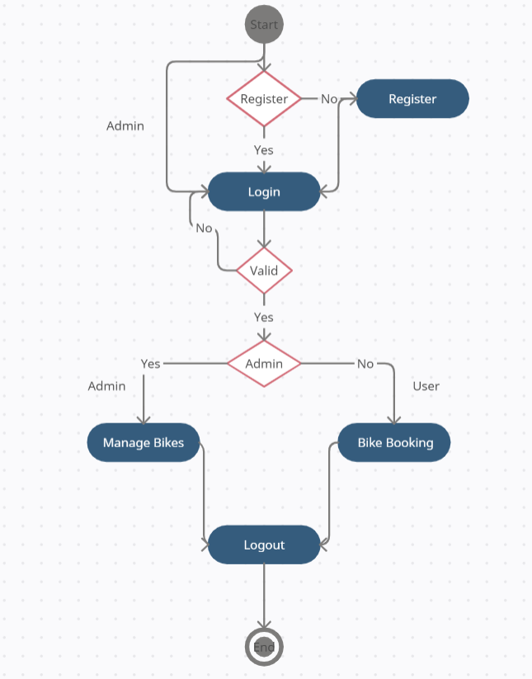

*Figure 1 Activity Diagram*

* **Add Bikes**

The rental system contains different kinds of bikes of different companies and variants. The Bikes can be classified into different companies. Admin can add new bike into the existing system with all its details including an image.

* **Delete Bike**

Administrator can delete the bike based on the availability of that particular bike.

* **Search Bike**

Admin will have a list view of all the existing Bike. He can also search for a particular Bike by company name.

* **Manage Rents**

Admin have the privilege to change bike rent.

* **Update Bike**

Only admin is having the privilege to update bike details.

* + - 1. **Customer:**
* **Customer sign in, sign out, register**

This feature is provided to customer so he can sign in, sign out and register for new customer.

* **Search Bike**

Customer can search the bike as per his wish in specific category.

* **Booking**

Customer can book a bike as per his requirements

* **Booking Details** Customer have a privilege to his booking he can see his booking details.
* **Payments** Customer have a privilege to his booking he can see his booking details.
* **Feedback**

Customer can give feedback about bikes.

* **Cancel Booking**

Customer can cancel the booking.

* + - 1. **Bikes:**
* **Bike Company** Companies can have different bikes which are available for booking
* **Bike variants** Bike can have different types of variants from same company
* **Bikes:** Company can have different bikes which is managed by admin and booked by customers

# SYSTEM ANALYSIS

System analysis is the process of gathering and interpreting facts, diagnosing problems, and using the information to recommend improvements on the system. System analysis is a problem-solving activity that requires intensive communication between the system users and system developers.

System analysis or study is an important phase of any system development process. The system is viewed as a whole, the inputs are identified, and the system is subjected to close study to identify the problem areas. The solutions are given as a proposal. The proposal is reviewed on user request and suitable changes are made. This loop ends as soon as the user is satisfied with the proposal.

* 1. **EXISTING SYSTEM**

The current system for booking is to visit the shop manually and from the available bikes choose the bike customer want and book the bike by payment of the price of the it.

* + - It is less user-friendly.
    - User must go to shop and select bike.
    - It is difficult to identify the required bike.
    - Description of the bike limited.
    - It is a time-consuming process.
    - Not in reach of distant users.

Bike Rental System service will help users to book a bike for some fee specified. Till now

there was no clear web-based UI to help the users to rent the vehicle. They had to

manually rent the vehicle through their offices. It was a difficult task to manage rental

vehicles. Keeping track of all the rental bikes was a problem.

* 1. **PROPOSED SYSTEM**

This Bike Rental System project will enable the user to rent a vehicle. The user shall login

to the system and check for availability of bikes. The user specifies a type of bike and the

journey date and time. The Bike Rental System shall check for the availability of the bike

and rent the bike to the customer. The user can make payment online. The tool is designed

using Spring boot and ReactJS. All the data regarding the rental bikes are stored in MySQL database. The user

has to enter his name, address, phone details and check for the bikes available for rent.

The UI is very simple and the connectivity to back end is robust. The main advantage is

that the user shall be able to choose a bike depending on his budget.

* 1. **SYSTEM REQUIREMENT SPECIFICATION**
     1. **GENERAL DESCRIPTION**

**Product Description:**

The system consists of two parts. A web application which can provide the online booking for the customer to access the web service from his Smartphone/System. Web application should be able to help the customer for selecting his item and to help the owner in managing the orders from the customers.

**Problem Statement:**

As online bike booking became a trend nowadays the regular shops are losing their customers to online brands. Customers have effortless booking experience and saving time through booking online. For competing with those online brands, if shops are providing an online portal where their customers can book through internet and get the bikes as they want to ride and it will increase the number of customers

* + 1. **SYSTEM OBJECTIVES**
       - To provide a Web application for online booking of bikes in an existing shop.
       - To provide an online bike booking web site for the same shop.
    2. **SYSTEM REQUIREMENTS**
       1. **NON-FUNCTIONAL REQUIREMENTS**
          1. **EFFICIENCY REQUIREMENT**

When an online bike booking android application implemented customer can purchase product in an efficient manner. The system must provide easy and fast access without consuming more cost.

* + - * 1. **RELIABILITY REQUIREMENT**

The system should provide a reliable environment to both customers and owner. All bookings should be reaching at the admin without any errors.

* + - * 1. **USABILITY REQUIREMENT**

The Web application is designed for user friendly environment and ease of use.

* + - * 1. **IMPLEMENTATION REQUIREMENT**

Implementation of the system using React in front end with Spring Boot as back end and it will be used for database connectivity. And the database part is developed by MySQL. Responsive web designing is used for making the website compatible for any type of screen.

* + - * 1. **DELIVERY REQUIREMENT**

The whole system is expected to be delivered in four months of time with a weekly Evaluation by the project guid

* + - 1. **FUNCTIONAL REQUIREMENTS**
* **CUSTOMER**

**LOGIN**

**Description of feature**

This feature used by the customer to login into system. A customer must login with his username and password to the system after registration. If they are invalid, the user not allowed to enter the system.

**Functional Requirement**

* Username and password will be provided after user registration is confirmed.
* Password should be hidden from others while typing it in the field
* **REGISTER NEW USER**

**Description of feature** A new user will have to register in the system by providing essential details in order to view the products in the system. The admin must accept new user by unblocking him.

**Functional Requirement**

* System must be able to verify and validate information.
* The system must encrypt the password of the customer to provide security.
* **BOOKING BIKE**

**Description of feature** the customer can book the desired bikes by clicking book option on the bike. He can view his bookings by clicking on the booked bikes. All bikes booked by customer can be viewed in the booked bikes. Customer can cancel a booking. For confirming the booking customer have to pay the rent of the bike which confirms the booking. customer can give the feedback of bikes which are booked by him.

**Functional Requirement**

* System must ensure that, only a registered customer can purchase items.
* Admin account should be secured so that only owner of the shop can access that account

# MODERATOR

**Description of features**

A moderator is considered as a staff who can manage orders for the time being. As a future update moderator may give facility to add and manage his own products. Moderators can reduce the workload of admin. Now moderator has all the privilege of an admin having except managing other moderators. He can manage users and manage products. He can also check the orders and edit his profile.

**Functional Requirement**

* The system must identify the login of a moderator.

**ADMIN**

* **MANAGE CUSTOMER**

**Description of features**

The administrator can view customers who booked the bike. He can cancel the booking of customer

* **MANAGE MODERATOR**

**Description of features**

The administrator can add moderator, delete moderator, block moderator and search for a moderator.

* **MANAGE BIKES**

**Description of features**

The administrator can add bikes, delete bikes, view bikes and update bikes.

* **MANAGE BOOKINGS**

**Description of features**

The administrator can view bookings and cancel bookings.

**Functional Requirements:**

* The system must identify the login of the admin.
* Admin account should be secured so that only owner of the shop can access that account.
* **MODERATOR**

**Description of features**

A moderator is considered as a staff who can manage orders for the time being. As a future update moderator may give facility to add and manage his own products. Moderators can reduce the workload of admin. Now moderator has all the privilege of an admin having except managing other moderators. He can manage users and manage products. He can also check the orders and edit his profile.

**Functional Requirement**

* The system must identify the login of a moderator.

# SYSTEM DESIGN

System design is the solution for the creation of a new system. This phase focuses on the detailed implementation of the feasible system. Its emphasis on translating design. Specifications to performance specification. System design has two phases of development.

* Logical Design
* Physical Design

During logical design phase the analyst describes inputs (sources), outputs(destinations), databases (data sores) and procedures (data flows) all in a format that meets the user requirements. The analyst also specifies the needs of the user at a level that virtually determines the information flow in and out of the system and the data resources. Here the logical design is done through data flow diagrams and database design. The physical design is followed by physical design or coding. Physical design produces the working system by defining the design specifications, which specify exactly what the candidate system must do. The programmers write the necessary programs that accept input from the user, perform necessary processing on accepted data and produce the required report on a hard copy or display it on the screen.

* 1. **INPUT AND OUTPUT DESIGN**
     1. **INPUT DESIGN:**

Input design is the link that ties the information system into the world of its users. The input design involves determining the inputs, validating the data, minimizing the data entry and provides a multi-user facility. Inaccurate inputs are the most common cause of errors in data processing. Errors entered by the data entry operators can be controlled by input design. The user-originated inputs are converted to a computer-based format in the input design. Input data are collected and organized into groups of similar data. Once identified, the appropriate input media are selected for processing. All the input data are validated and if any data violates any conditions, the user is warned by a message. If the data satisfies all the conditions, it is transferred to the appropriate tables in the database. In this project the student details are to be entered at the time of registration. A page is designed for this purpose which is user friendly and easy to use. The design is done such that users get appropriate messages when exceptions occur.

* + 1. **OUTPUT DESIGN:**

Computer output is the most important and direct source of information to the user. Output design

is a very important phase since the output needs to be in an efficient manner. Efficient and intelligible output design improves the system relationship with the user and helps in decision making. Allowing the user to view the sample screen is important because the user is the ultimate judge of the quality of output. The output module of this system is the selected notifications.

# DATABASE DESIGN

* 1. **DATABASE**

Databases are the storehouses of data used in the software systems. The data is stored in tables inside the database. Several tables are created for the manipulation of the data for the system. Two essential settings for a database are

* Primary key - the field that is unique for all the record occurrences
* Foreign key - the field used to set relation between tables Normalization is a technique to avoid redundancy in the tables.
  1. **SYSTEM TOOLS**

The various system tools that have been used in developing both the front end and the back end of the project are being discussed in this chapter.

* + 1. **FRONT END:**

React is a library which is developed by Facebook are utilized to implement the frontend. React (also known as React.js or ReactJS) is a [free and open-source](https://en.wikipedia.org/wiki/Free_and_open-source_software) [front-end](https://en.wikipedia.org/wiki/Front_end_and_back_end) [JavaScript](https://en.wikipedia.org/wiki/JavaScript_library) [library](https://en.wikipedia.org/wiki/JavaScript_library) for building [user interfaces](https://en.wikipedia.org/wiki/User_interfaces) or UI components. It is maintained by [Facebook](https://en.wikipedia.org/wiki/Facebook%2C_Inc) and a community of individual developers and companies. React can be used as a base in the development of [single](https://en.wikipedia.org/wiki/Single-page_application) [page](https://en.wikipedia.org/wiki/Single-page_application) or mobile applications. However, react is only concerned with state management and rendering that state to the [DOM,](https://en.wikipedia.org/wiki/Document_Object_Model) so creating React applications usually requires the use of additional libraries for routing, as well as certain client-side functionality.

* + 1. **BACKEND:**

The back end is implemented using MySQL which is used to design databases.

**MySQL:**

MySQL is the world's second most widely used open-source relational database management system (RDBMS). The SQL phrase stands for Structured Query Language. An application software called Navicert was used to design the tables in MySQL.

**Spring-Boot:**

This is used to connect MYSQL and fetch data from database and store the data in database. The Spring Framework is a[n application framework](https://en.wikipedia.org/wiki/Application_framework) and [inversion of control](https://en.wikipedia.org/wiki/Inversion_of_control) [container](https://en.wikipedia.org/wiki/Servlet_container) for the [Java](https://en.wikipedia.org/wiki/Java_platform) [platform.](https://en.wikipedia.org/wiki/Java_platform) The framework's core features can be used by any Java application, but there are extensions for building web applications on top of the [Java EE](https://en.wikipedia.org/wiki/Java_EE) (Enterprise Edition) platform. Although the framework does not impose any specific [programming model,](https://en.wikipedia.org/wiki/Programming_model) it has become popular in the Java community as an addition to the [Enterprise JavaBeans](https://en.wikipedia.org/wiki/Enterprise_JavaBeans) (EJB) model. The Spring Framework is Open-source Framework.

***Figure 1 Level DFD for ADMIN***

# 1 Level DFD for ADMIN

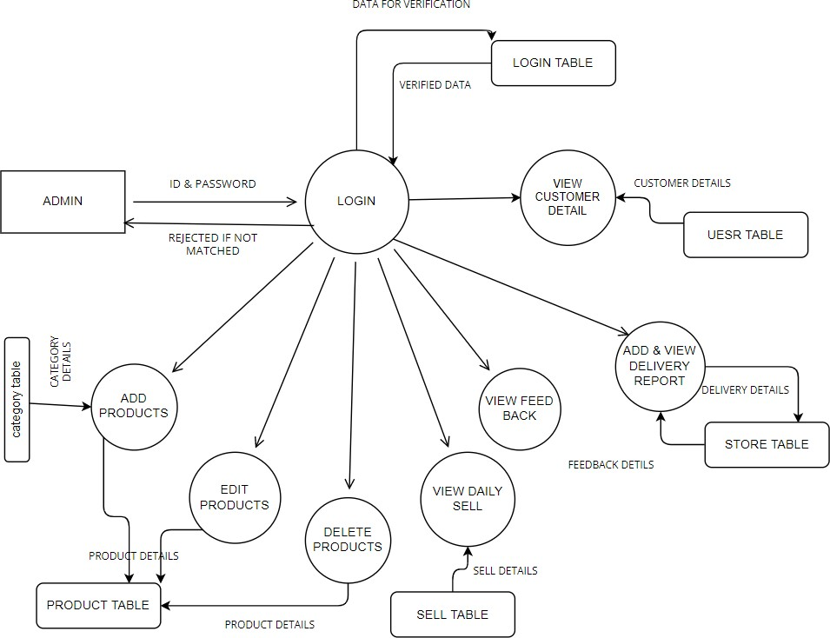

# 1 Level DFD for CUSTOMER

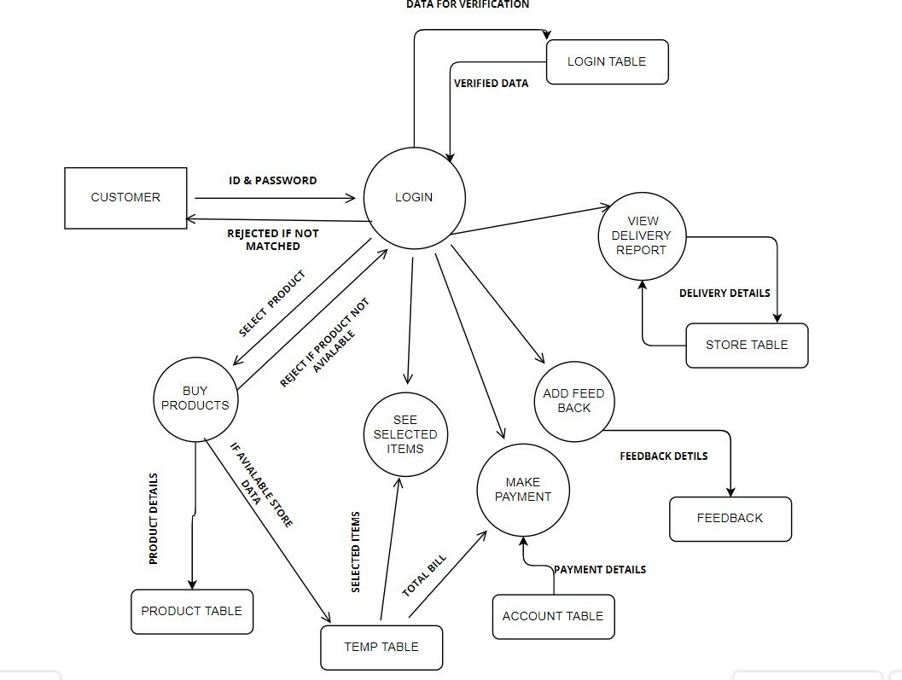

***Figure 6 1 Level DFD for CUSTOMER***

# E-R Diagram:

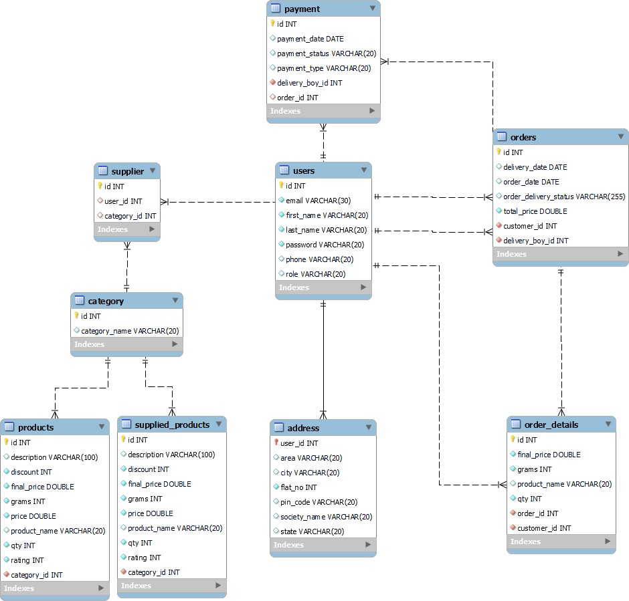

***Figure 7 E-R Diagram***

# Class Diagram

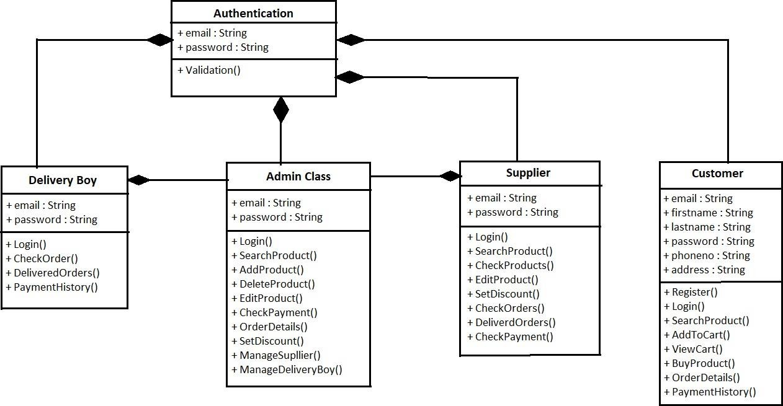

***Figure 8 Class Diagram***

# TABLE STRUCTURE:

**Tables:**

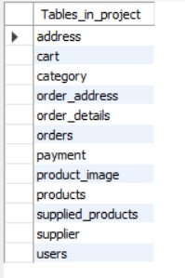

**Address:**

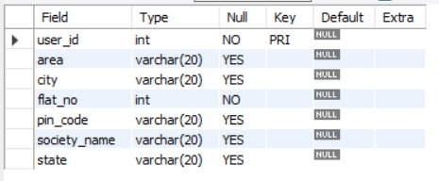

**Cart:**

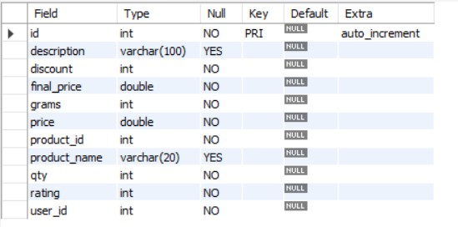

**Category:**

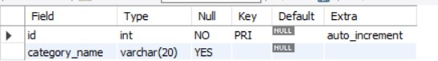

**Order Address:**

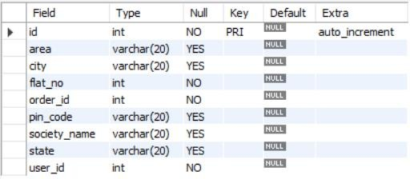

**Order Details:**

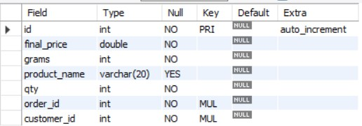

**Orders:**

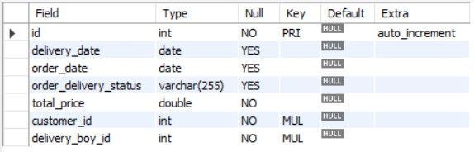

**Products:**

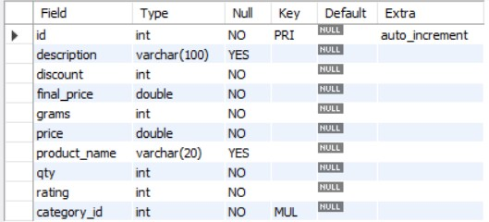

**Product Image:**

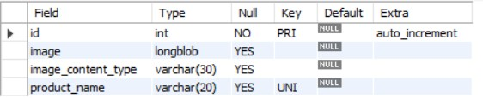

**Payment:**

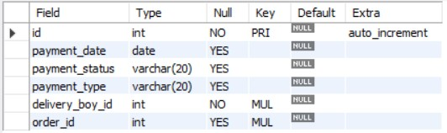

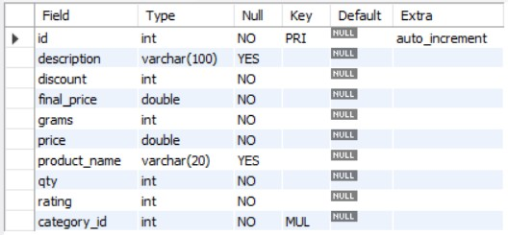**Supplied Products:**

**Supplier:**

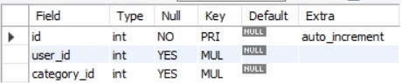

**Users:**

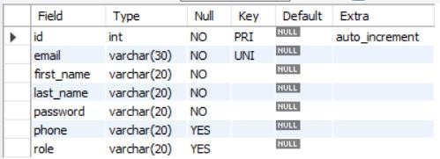

# PROJECT DIAGRAMS

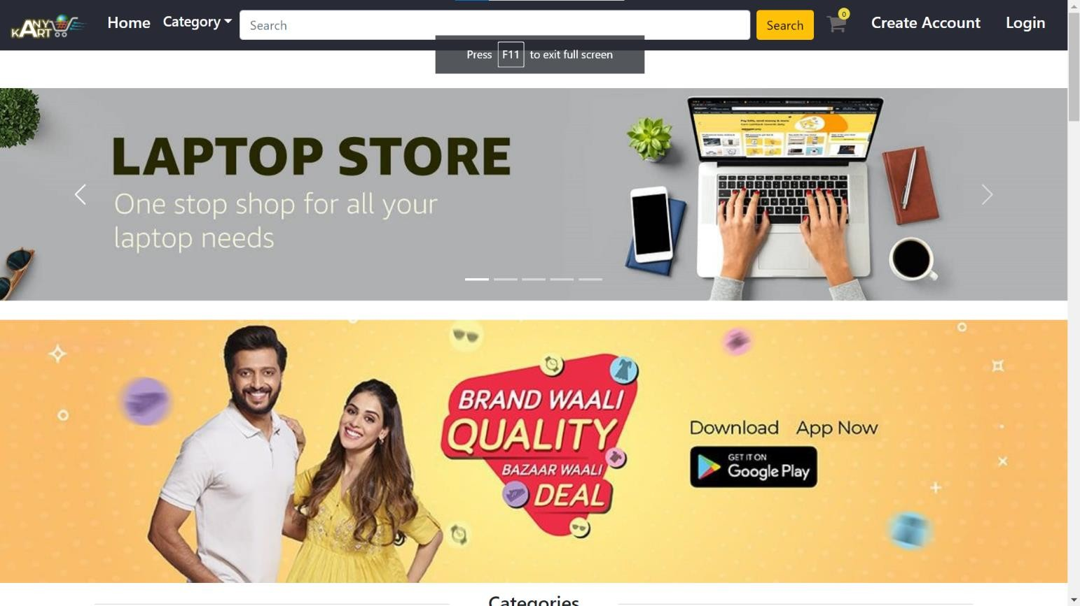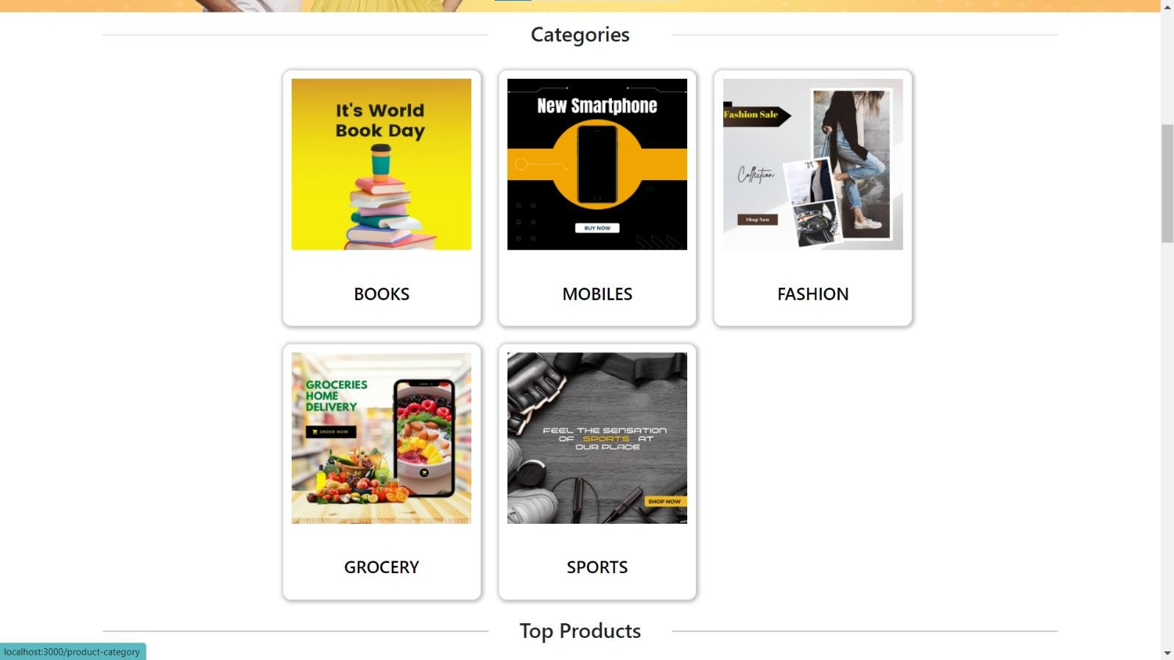

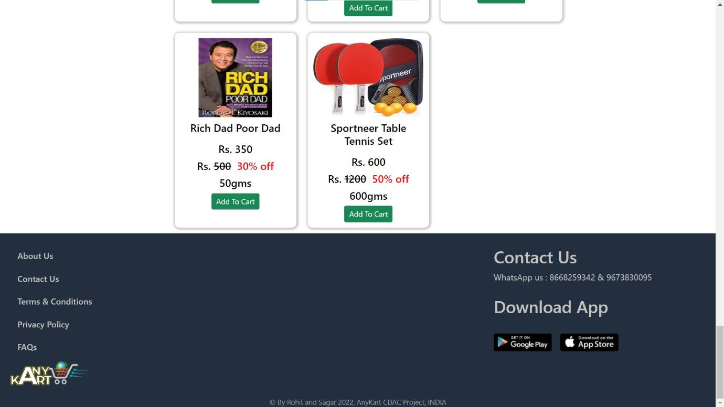

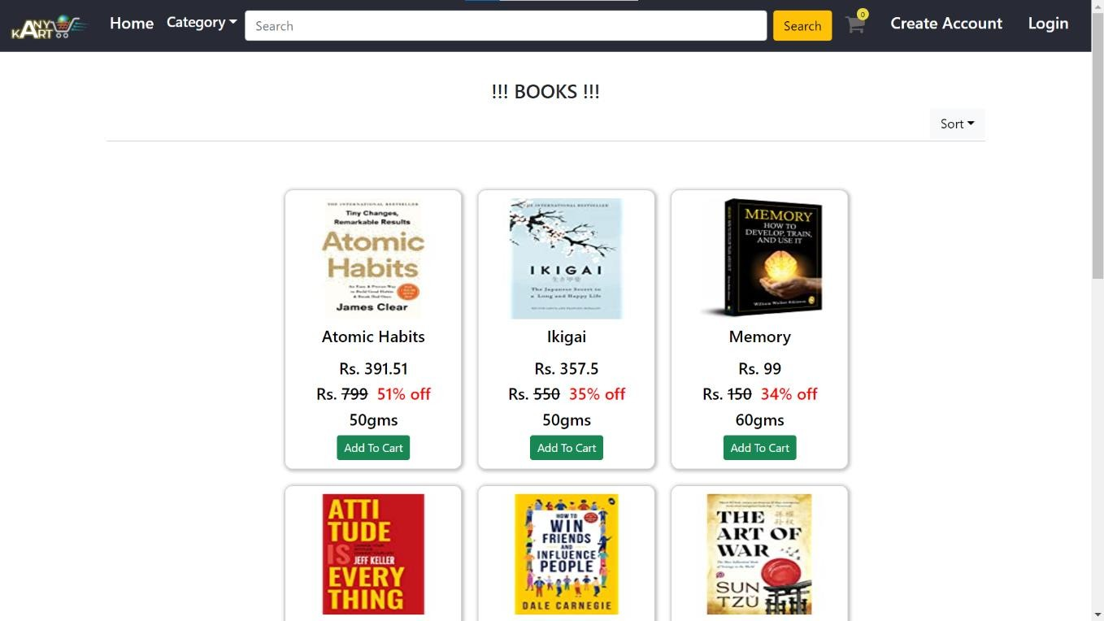

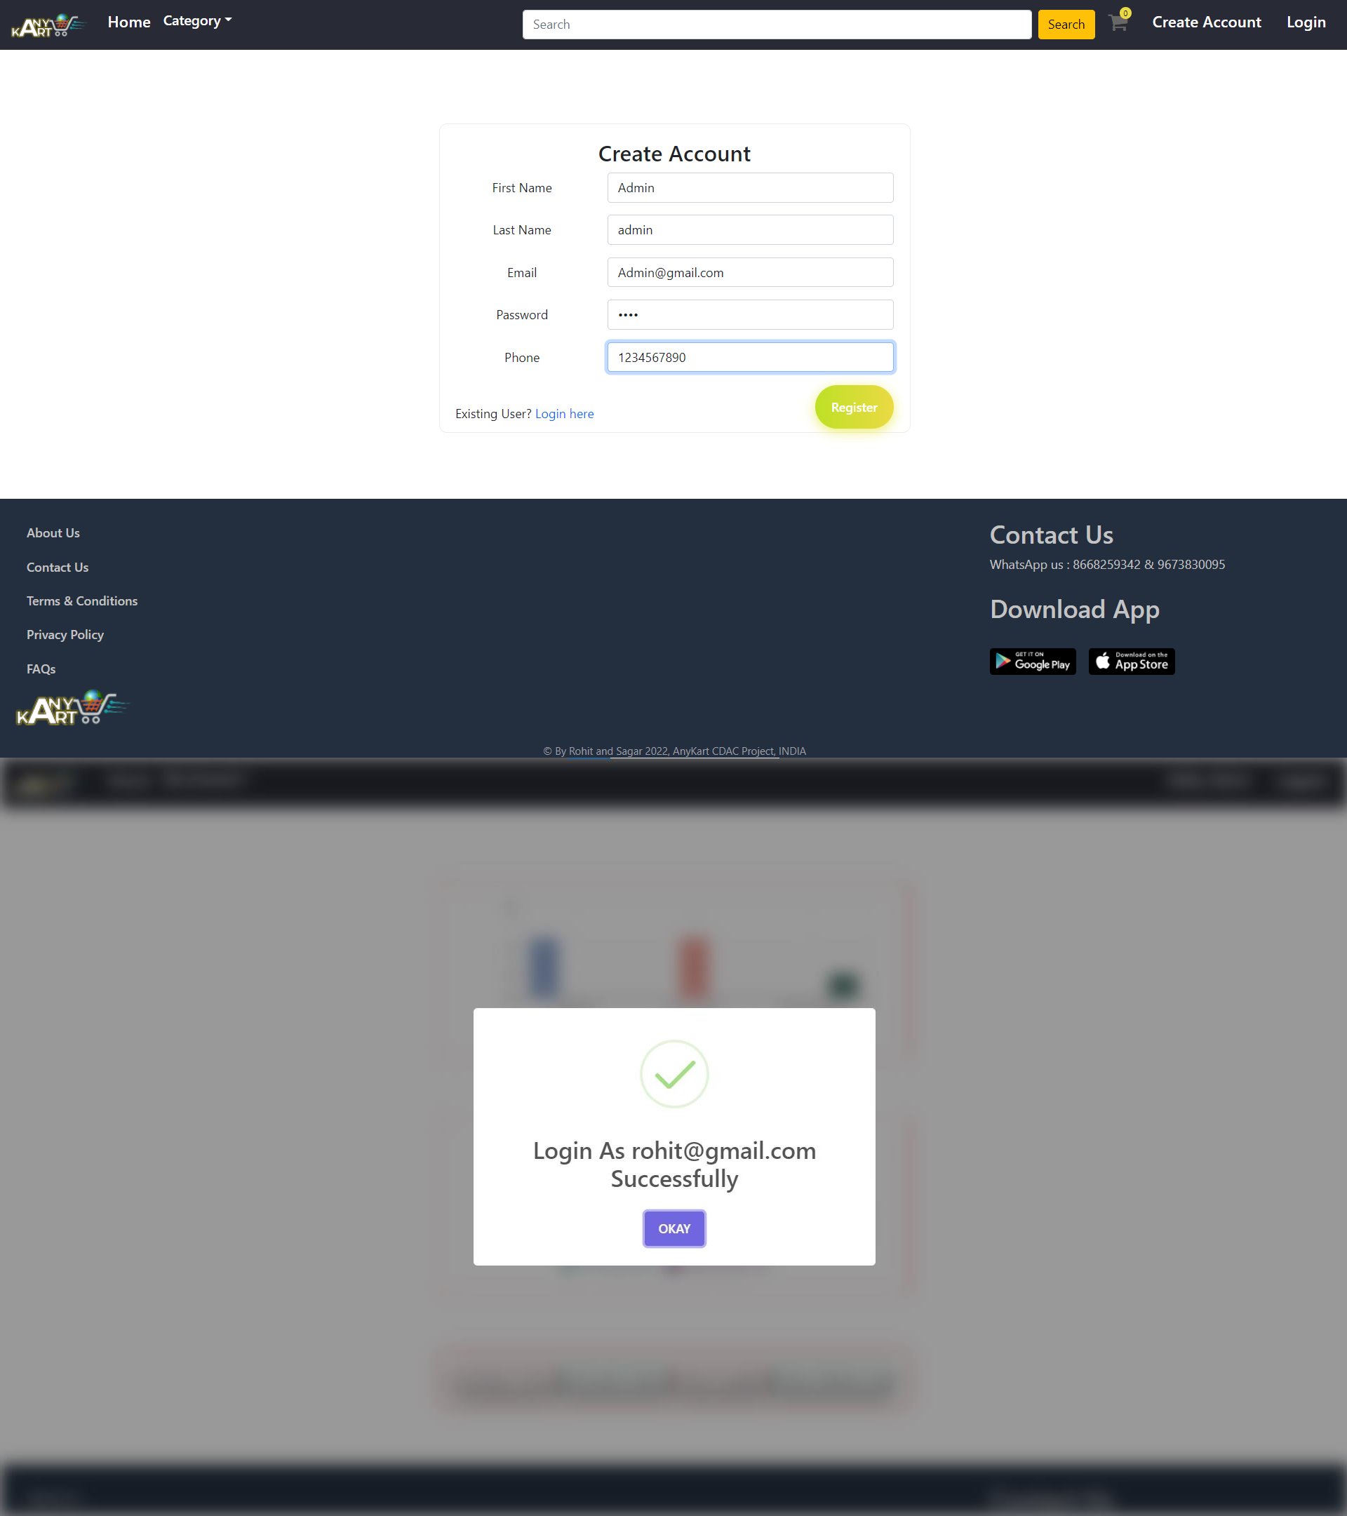

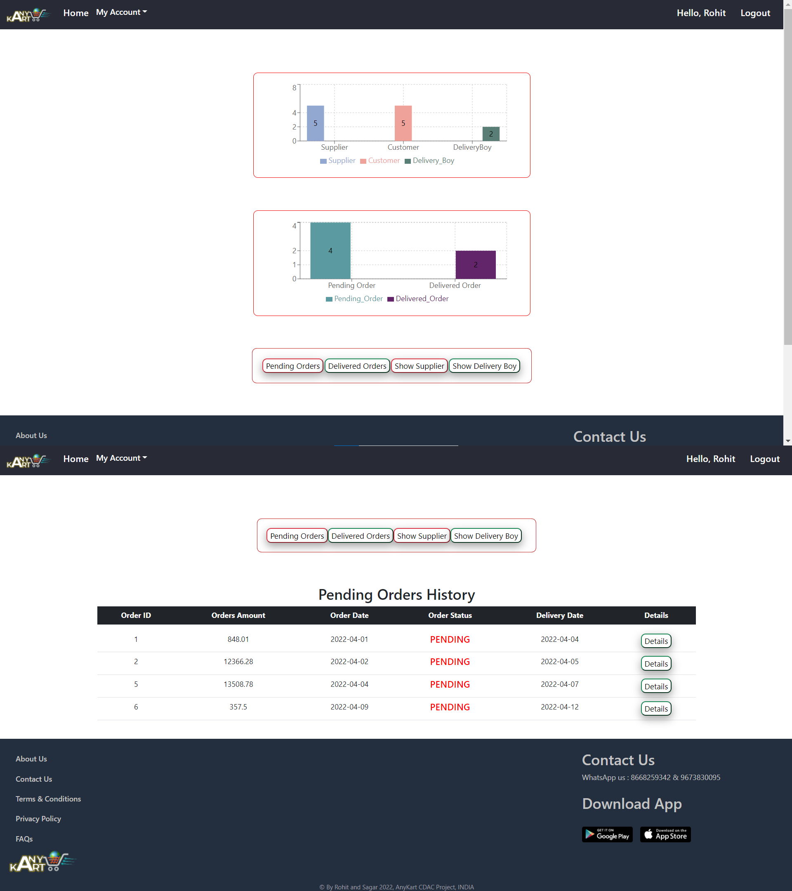

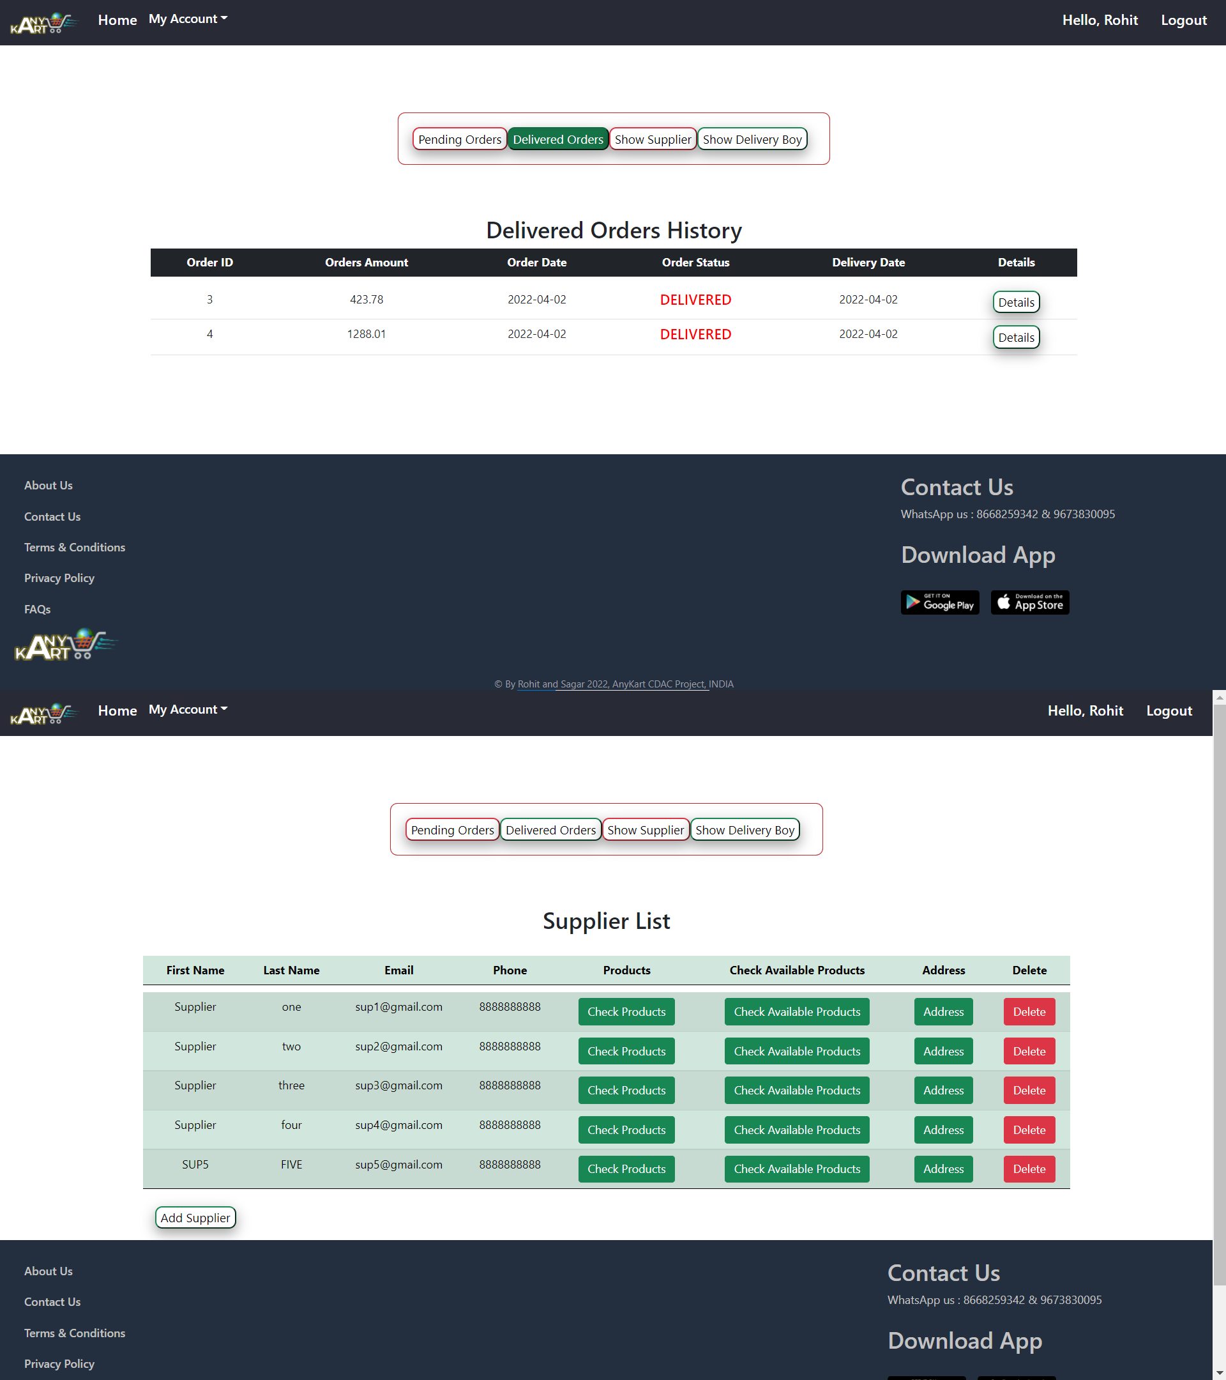

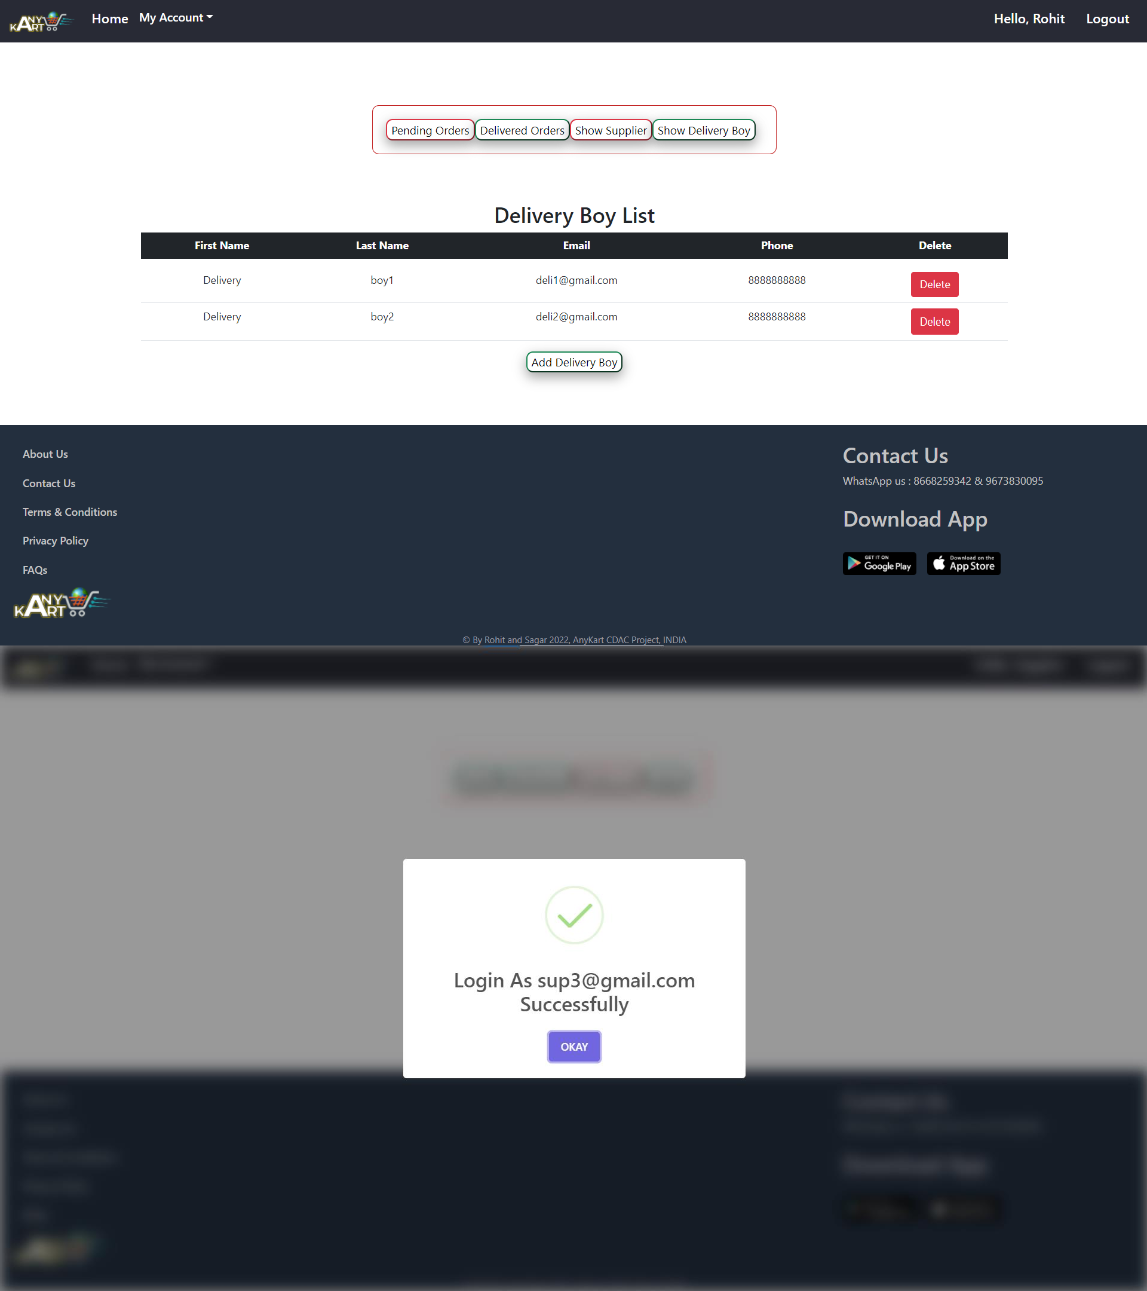

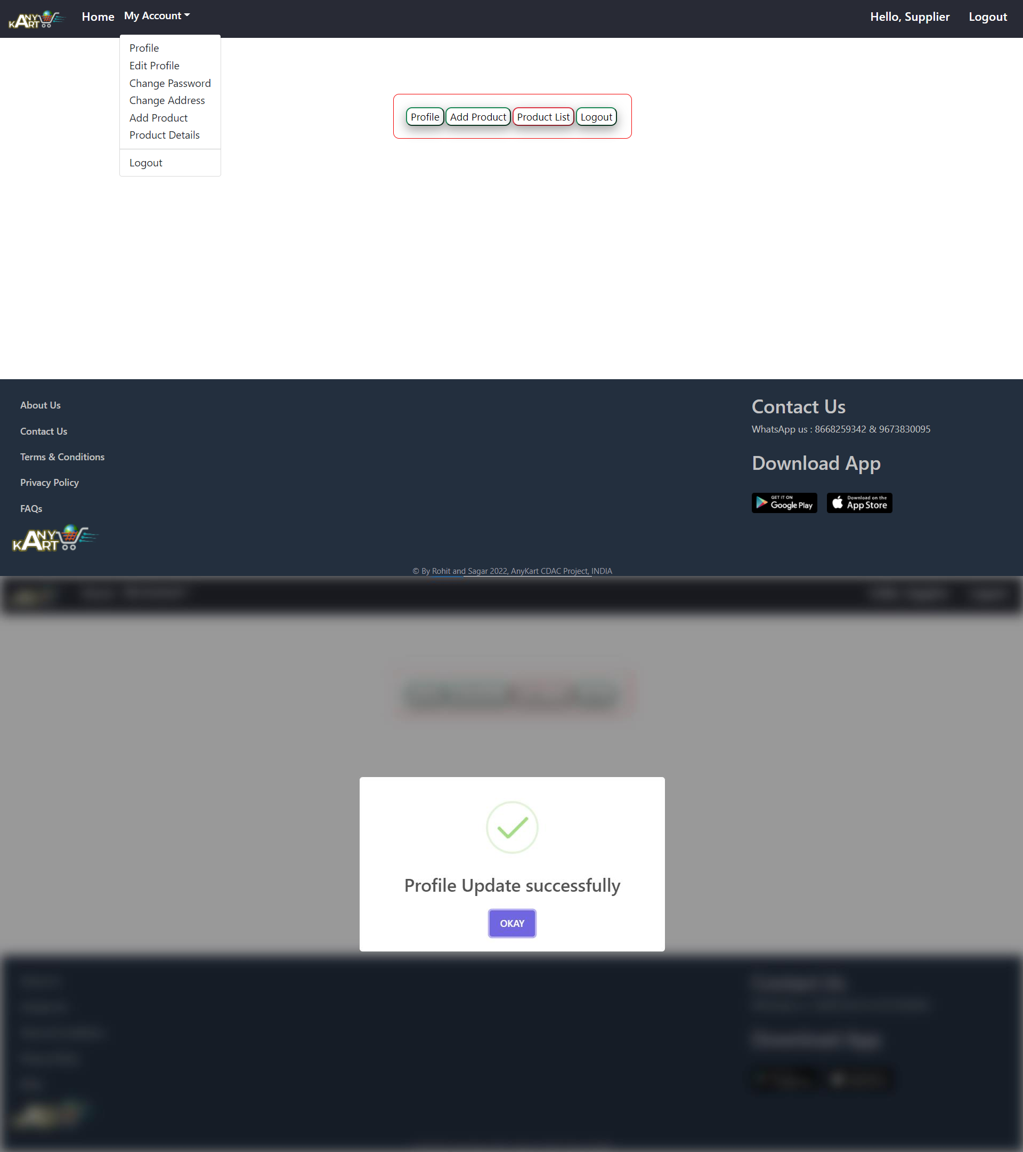

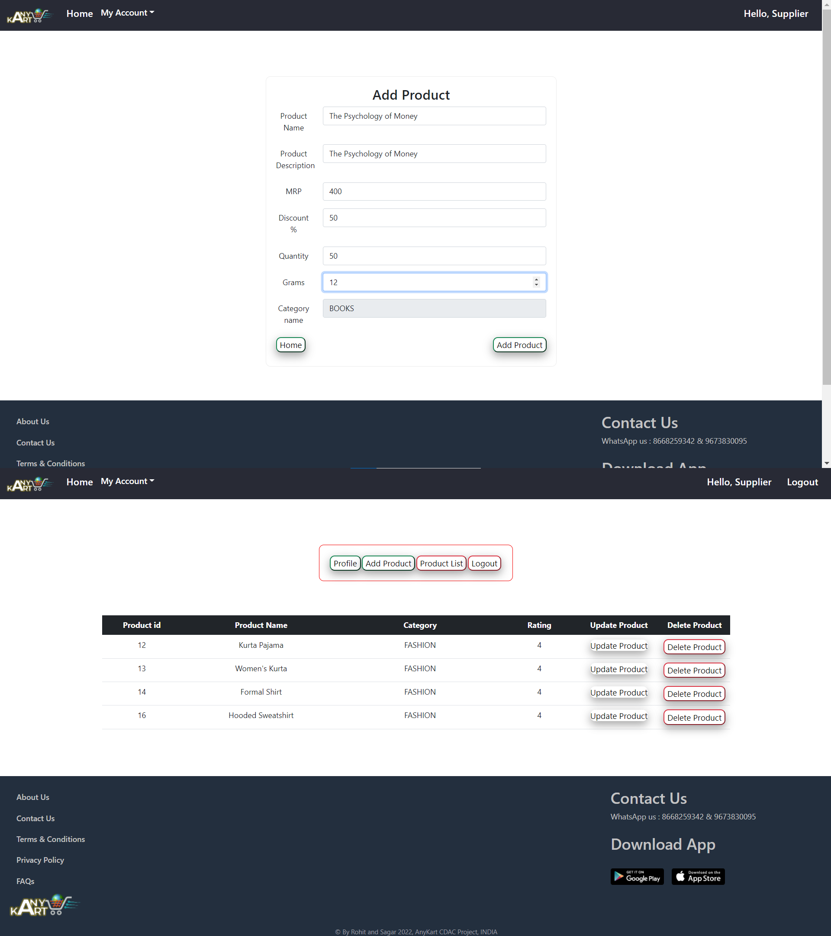

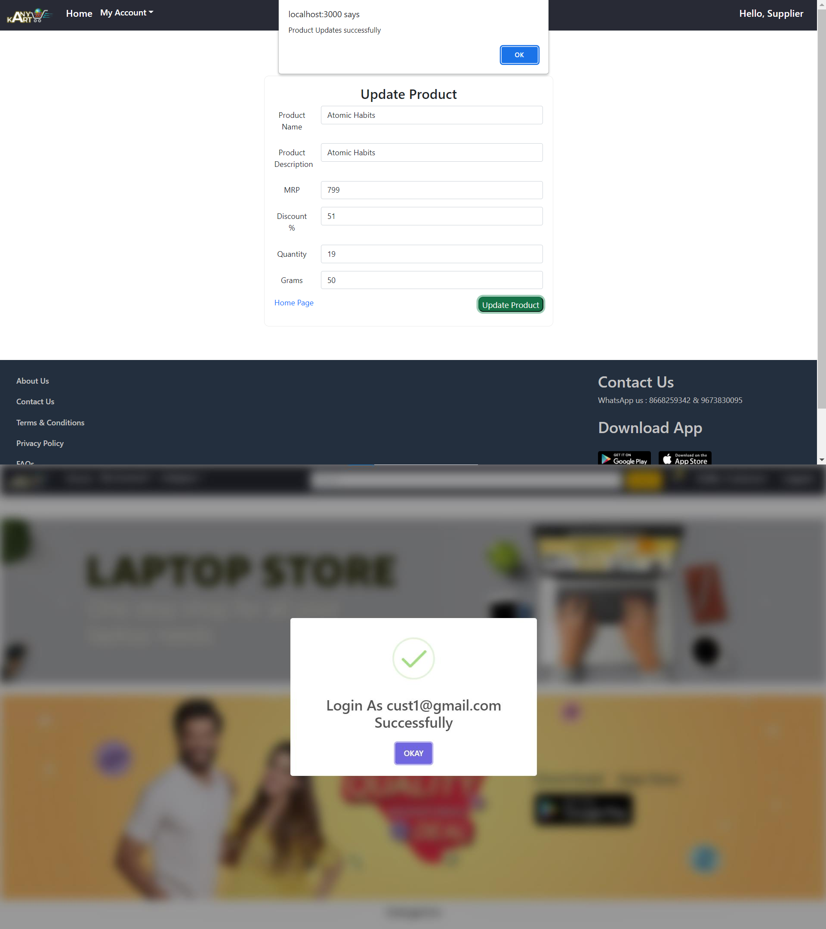

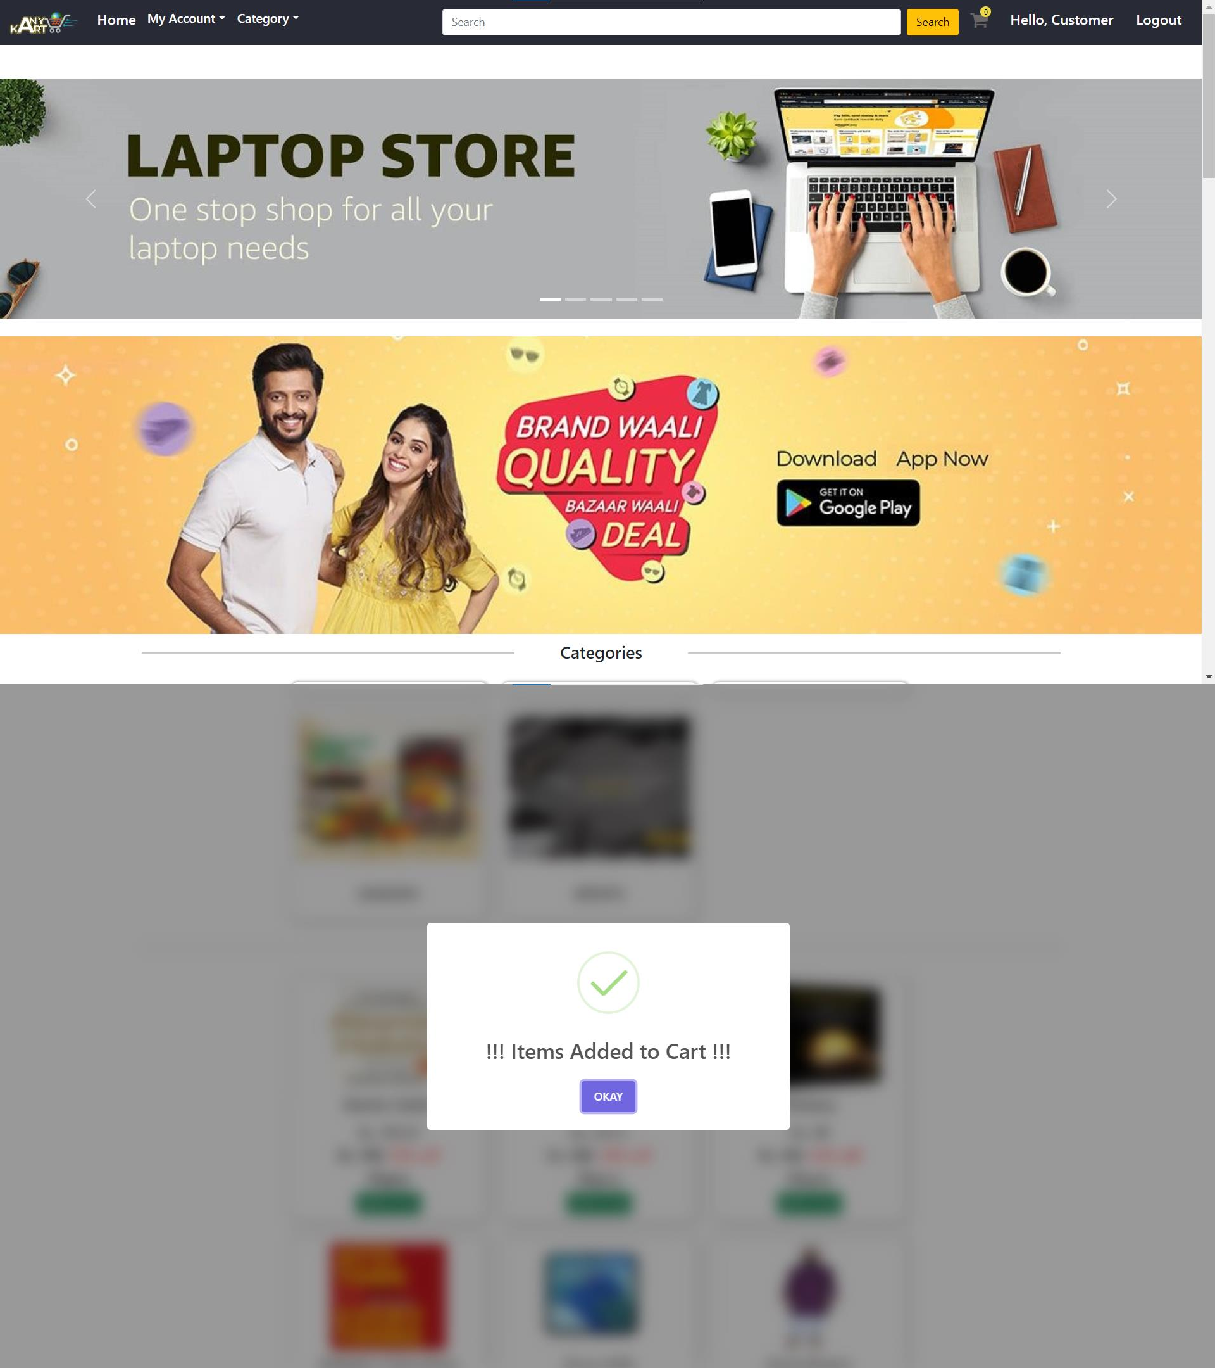

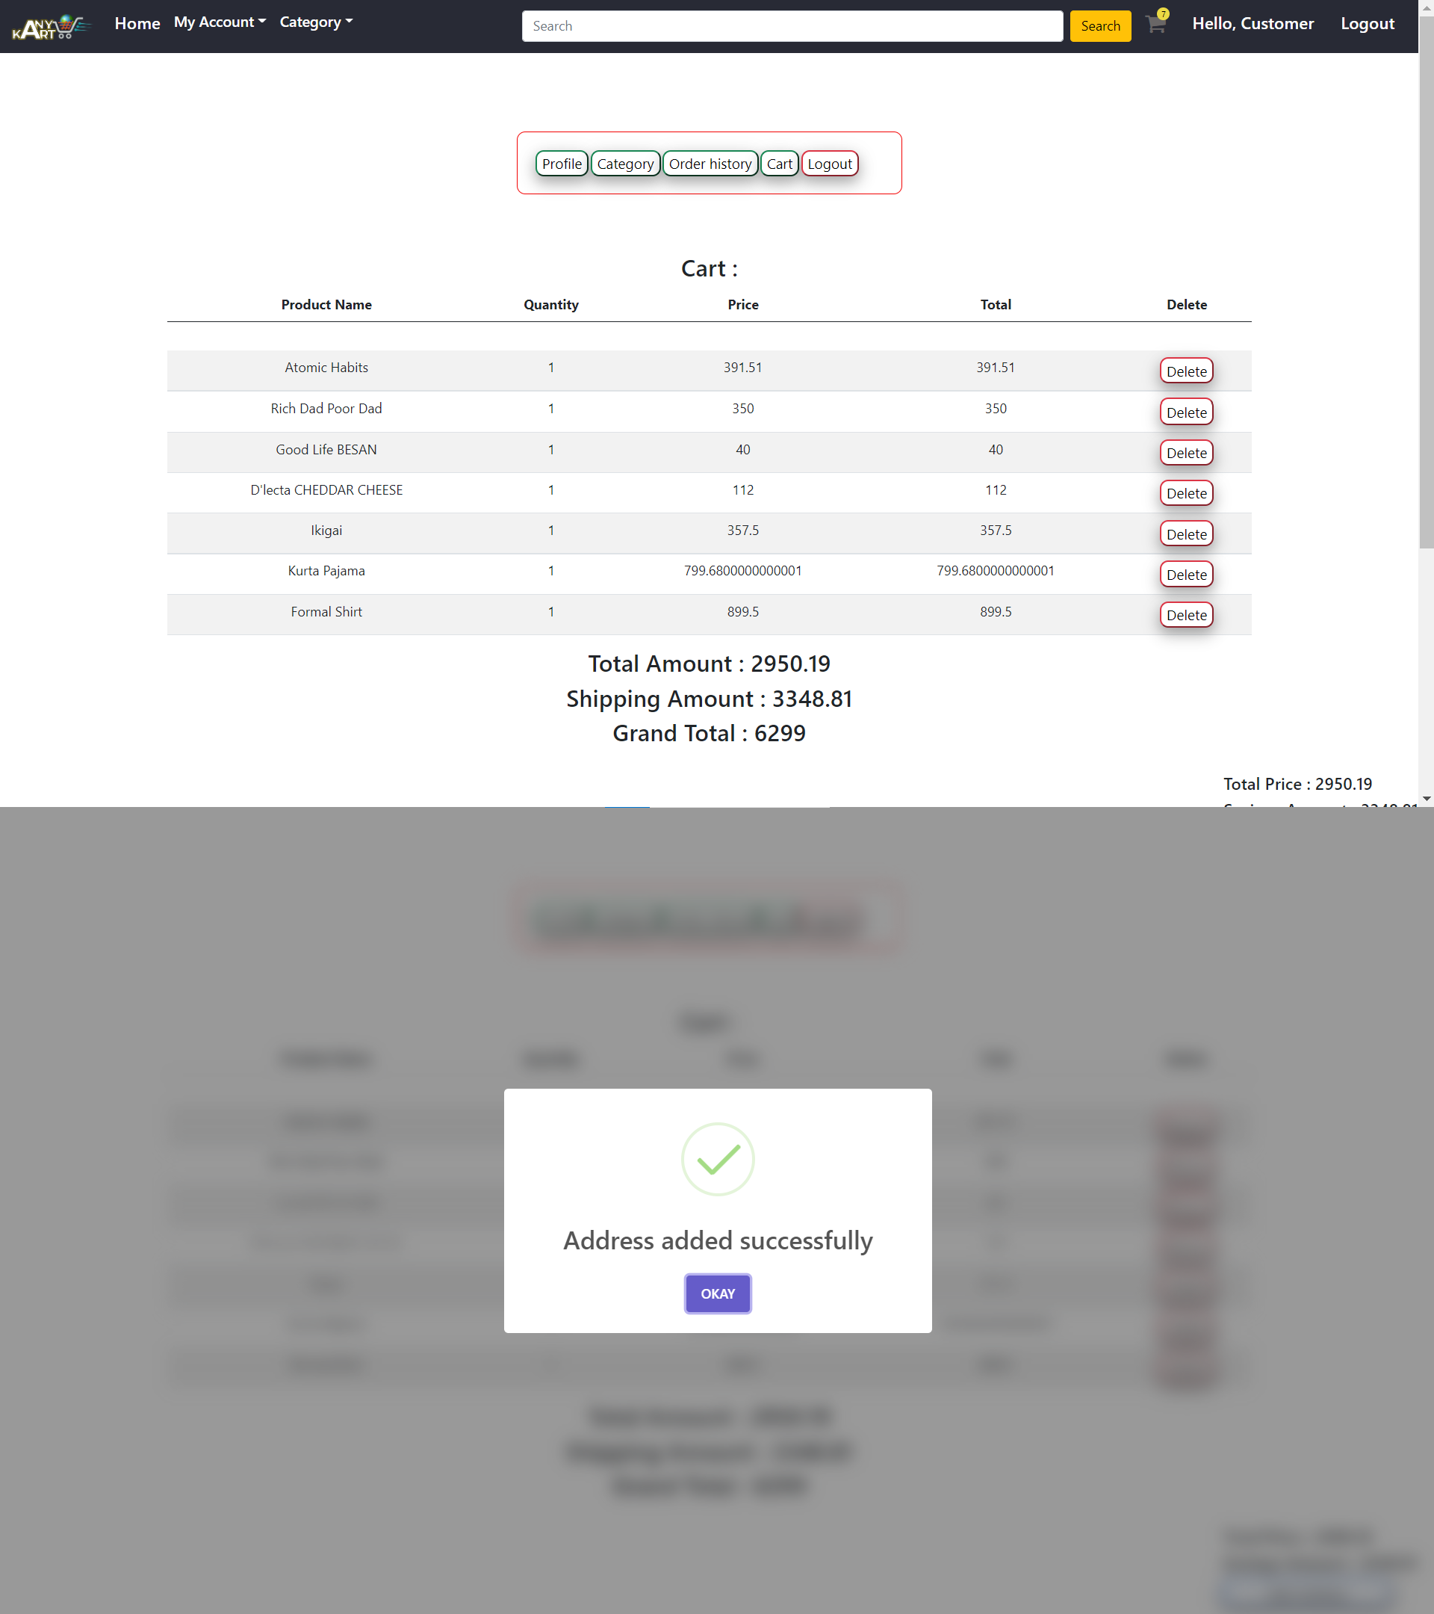

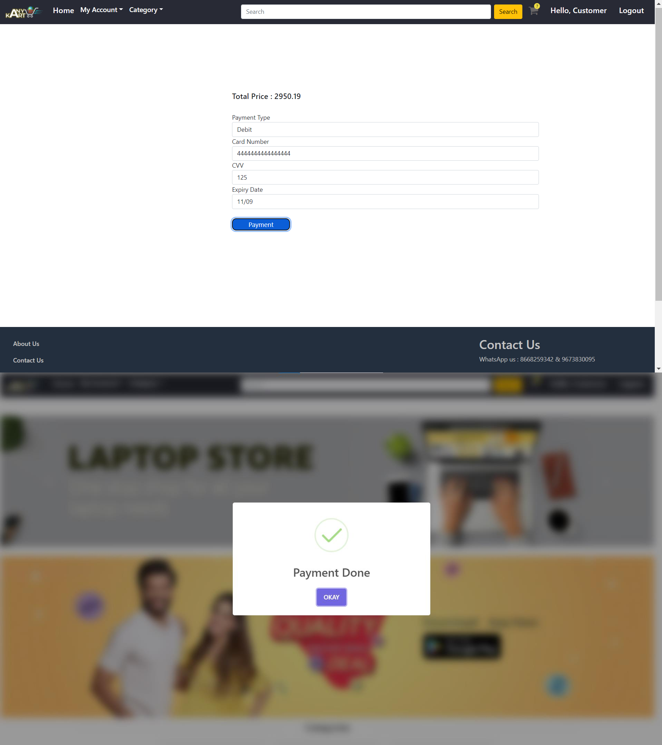

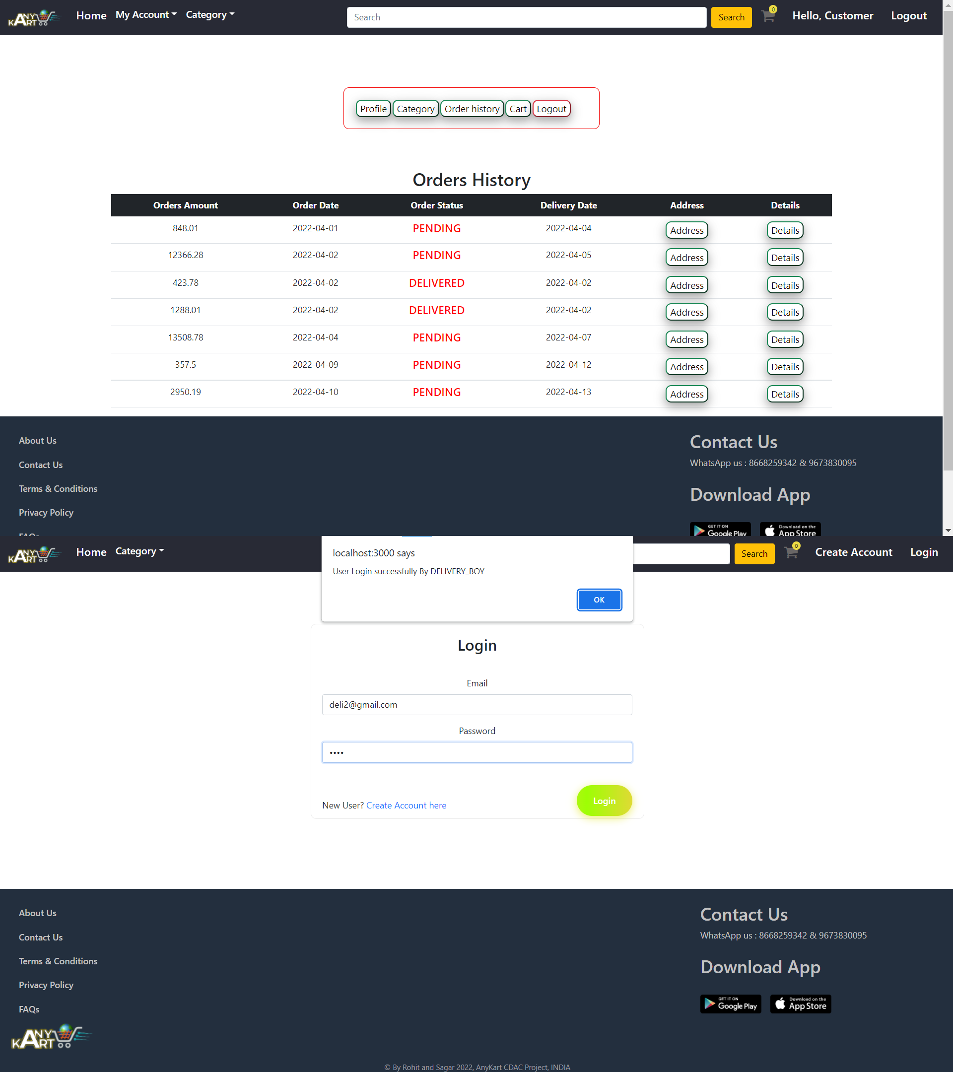

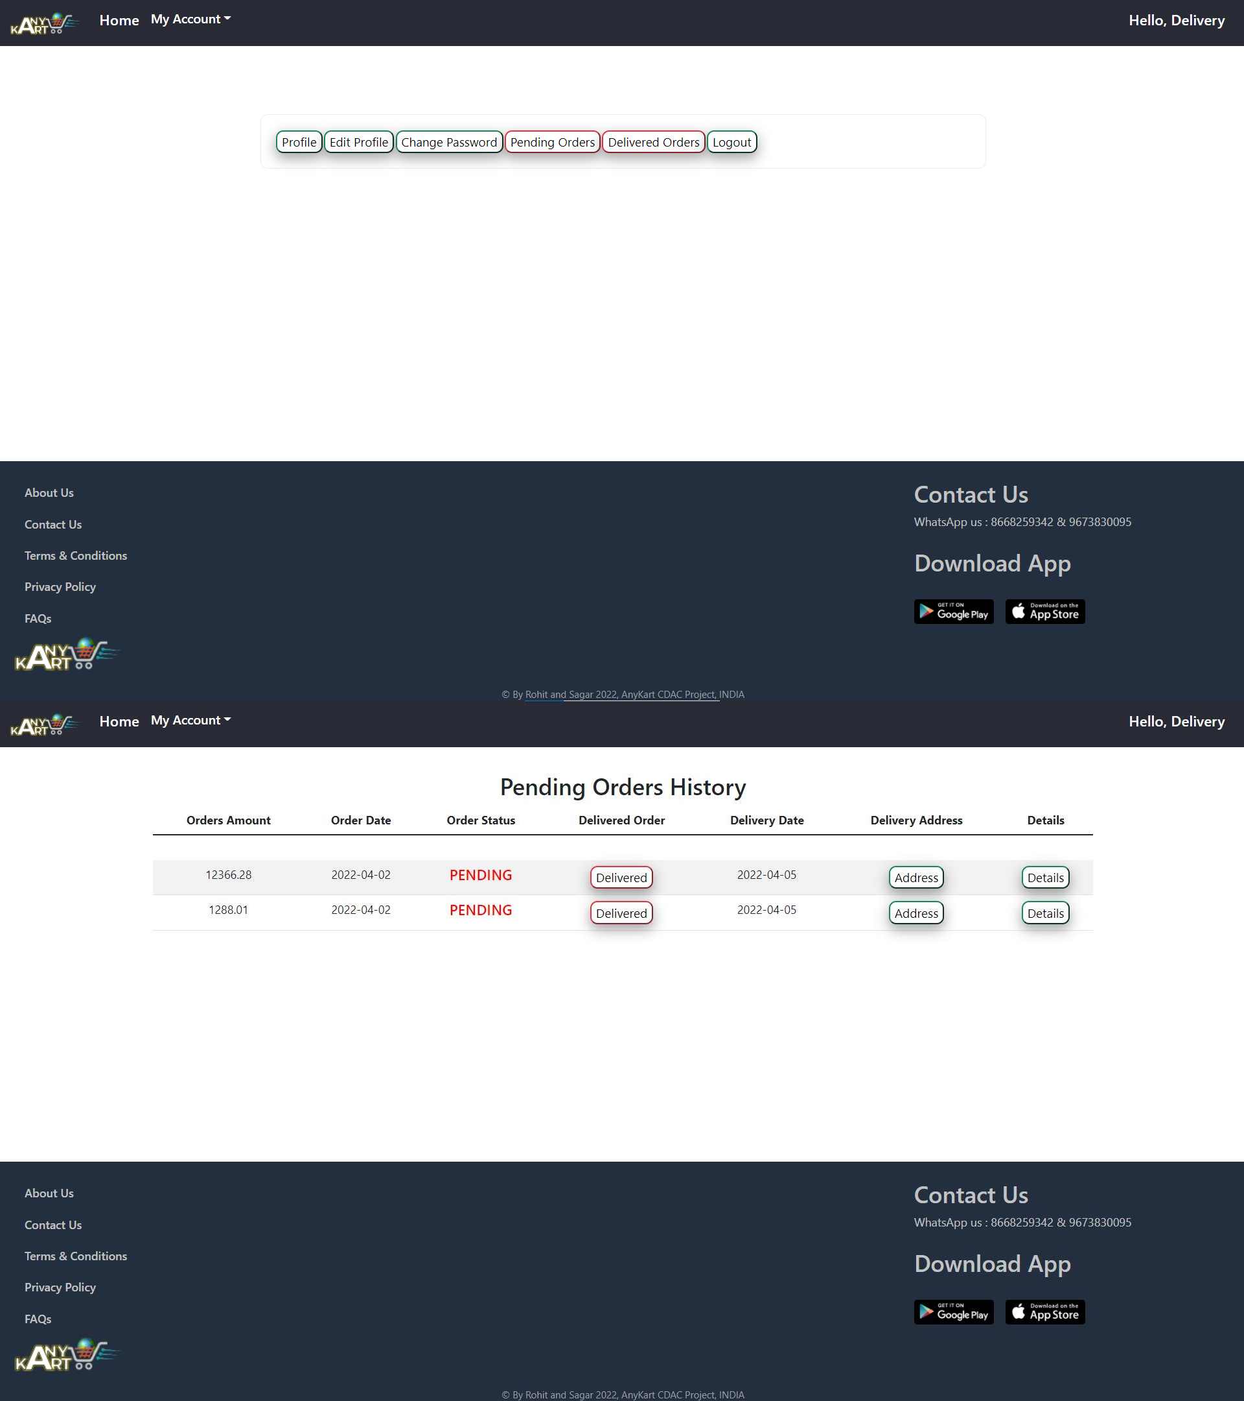

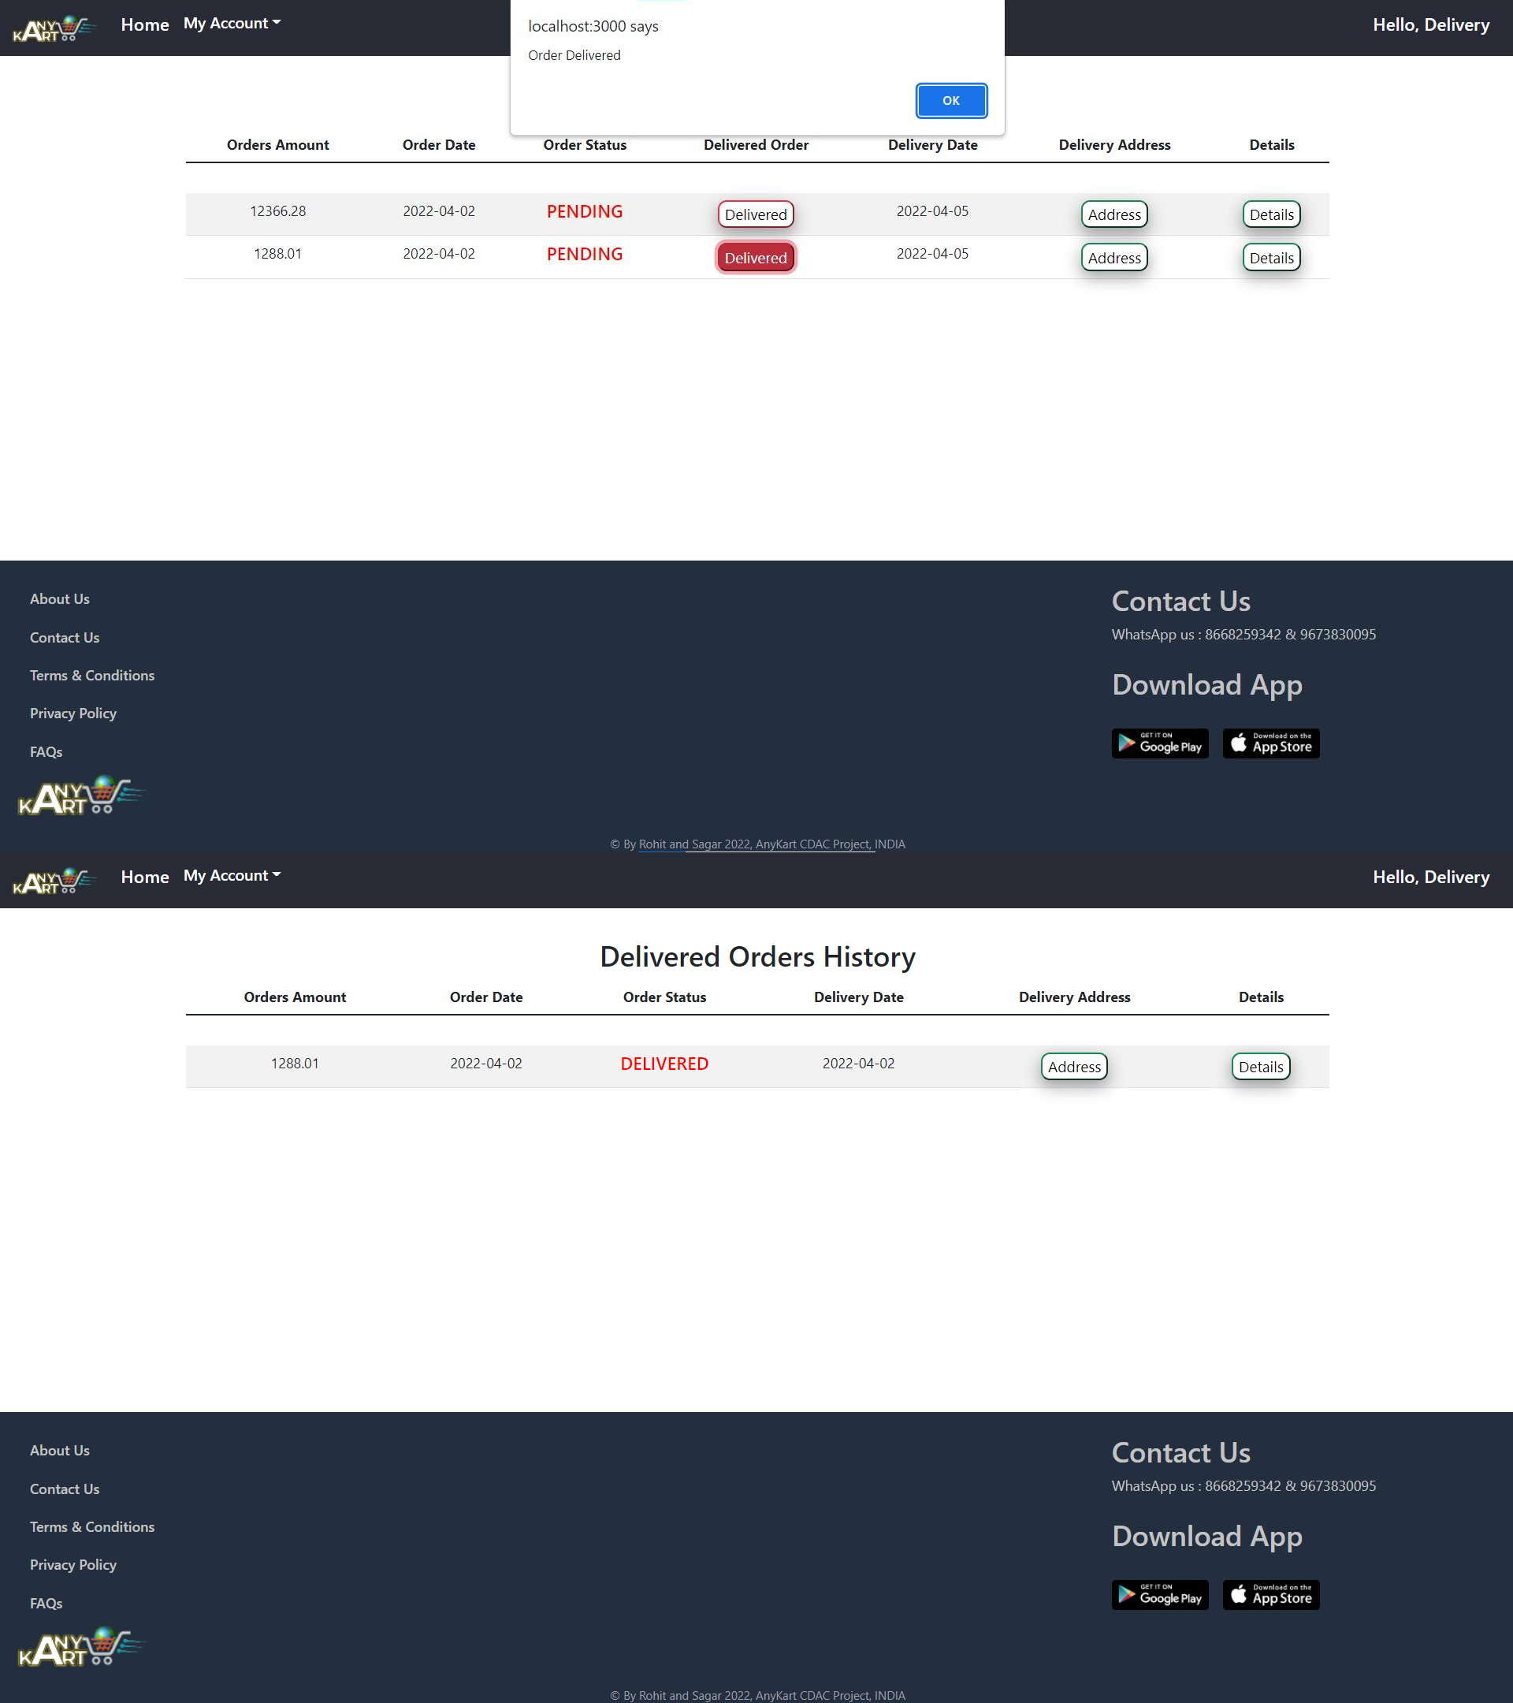

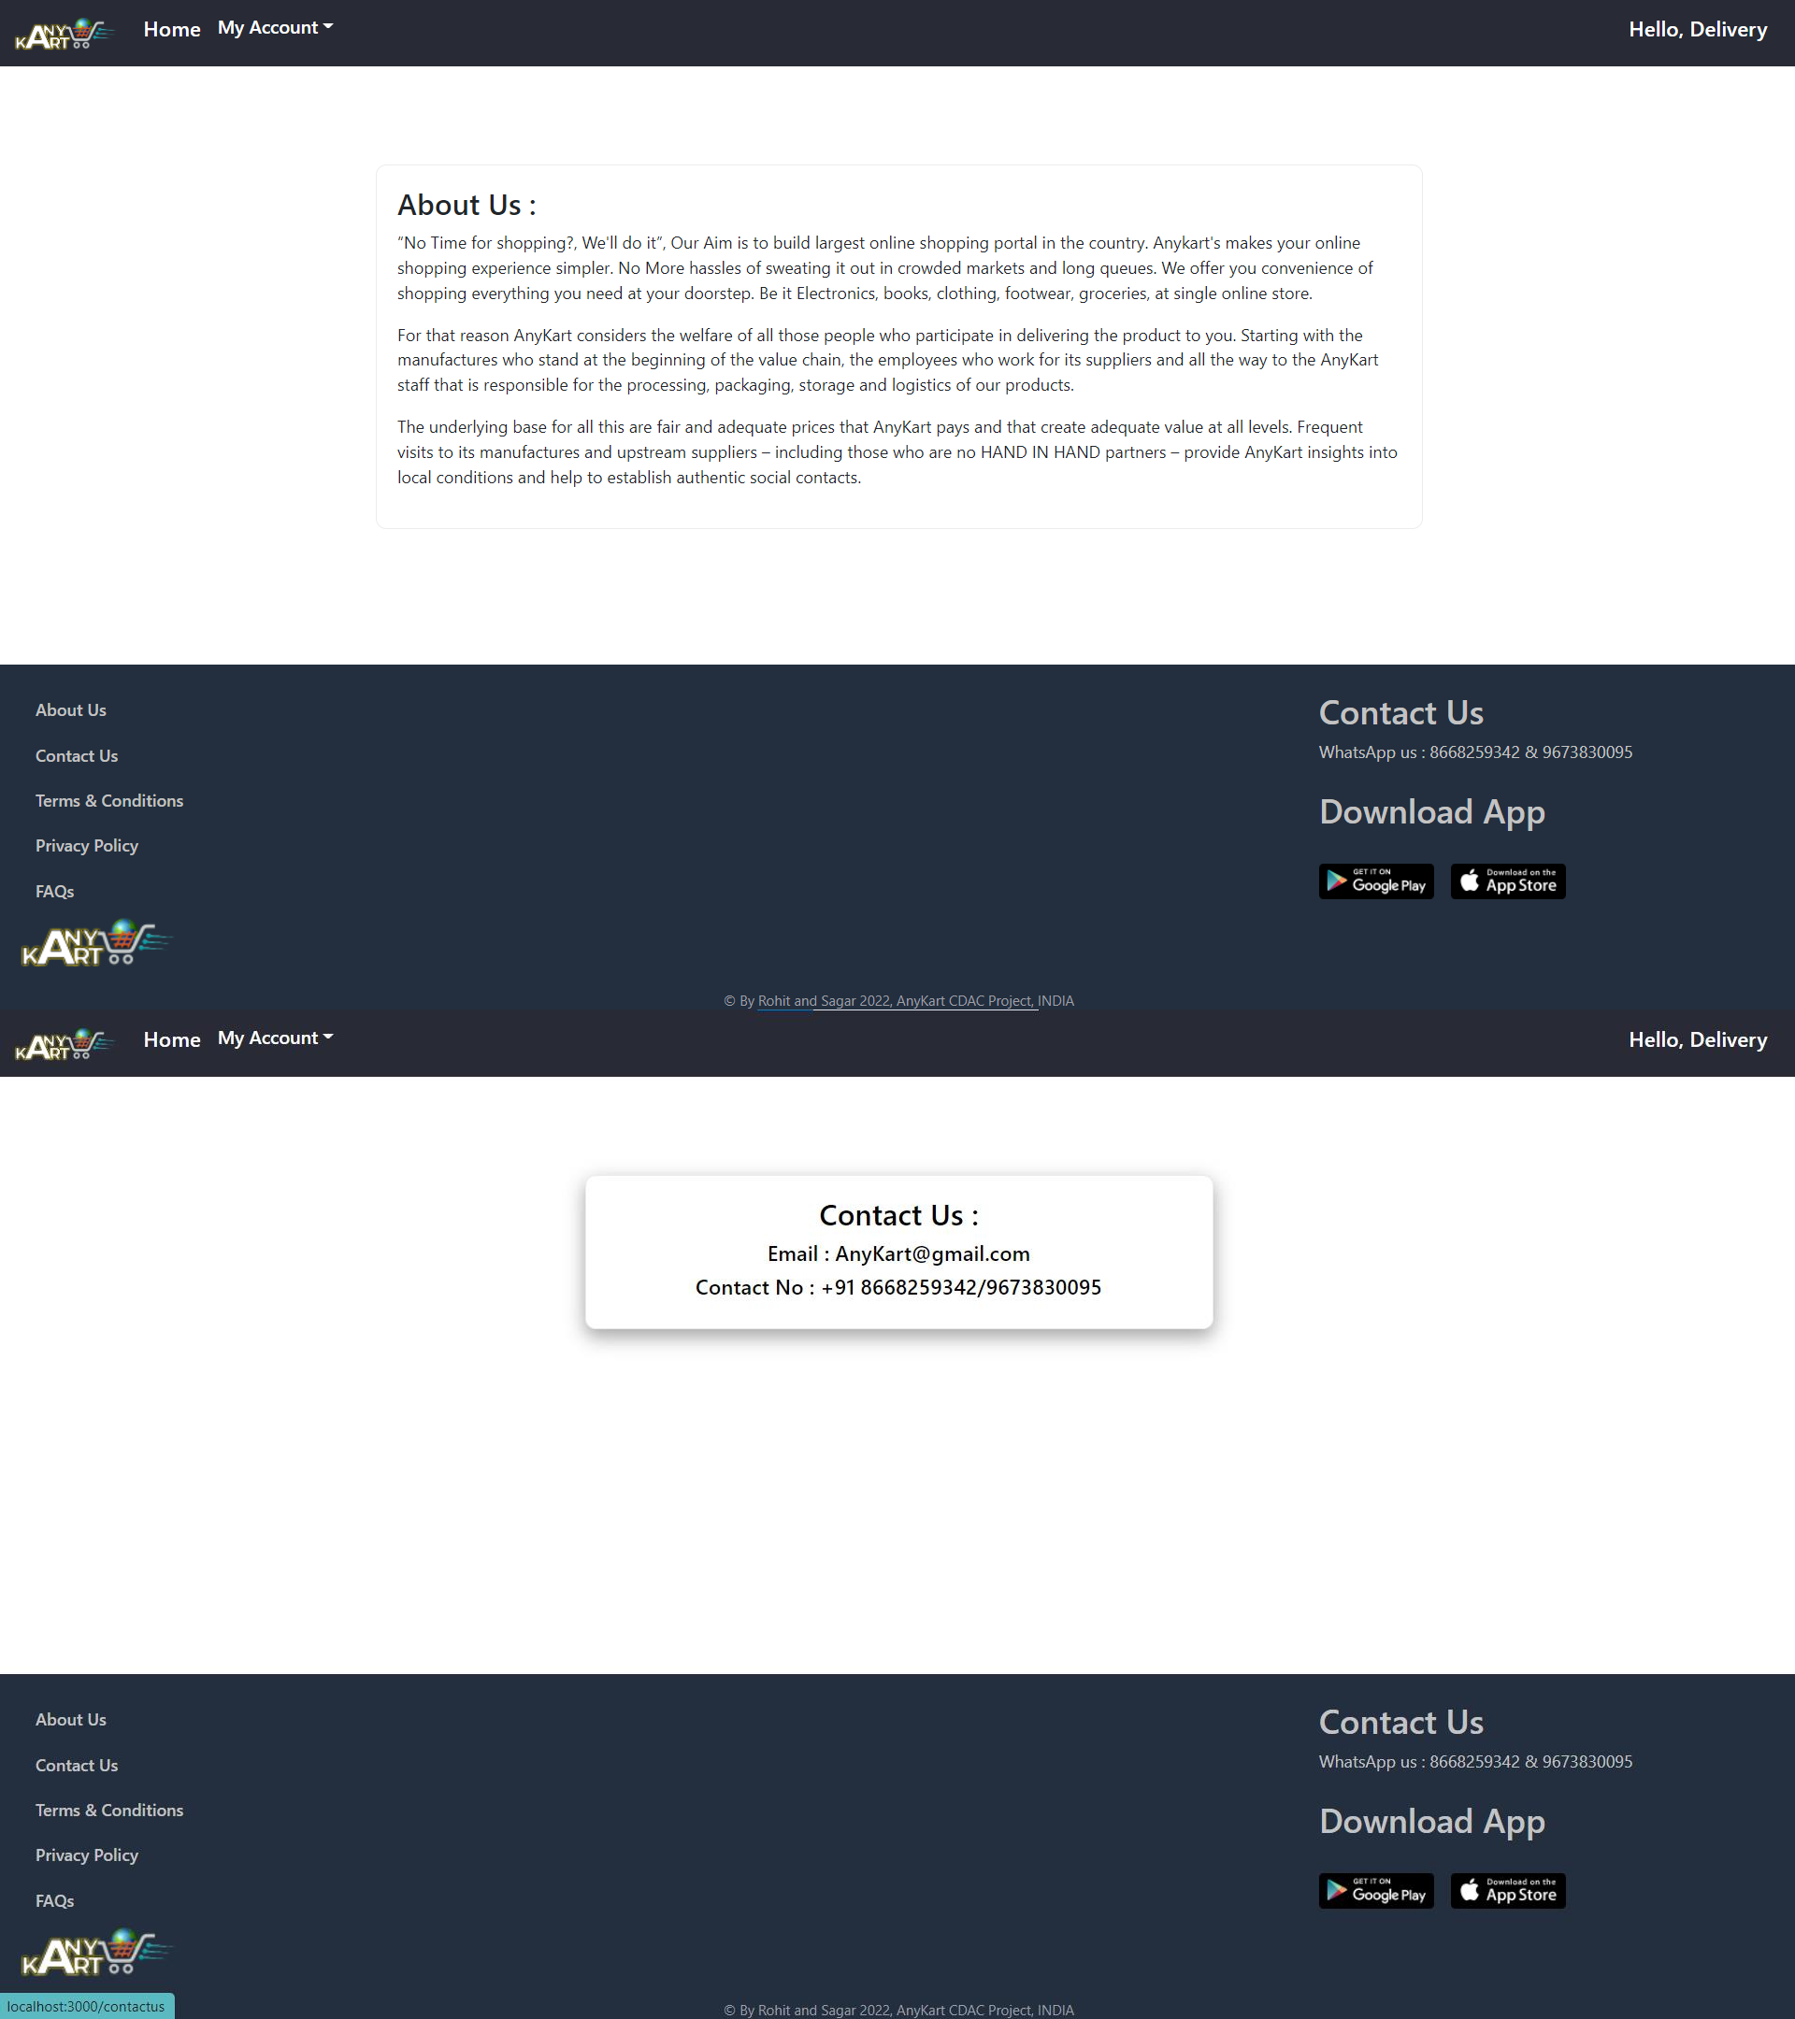

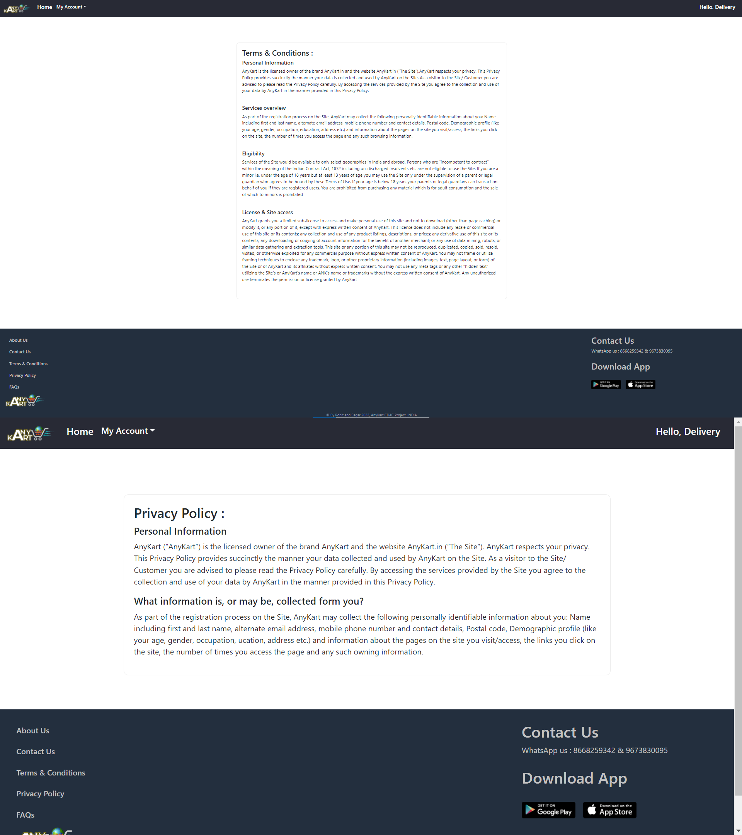

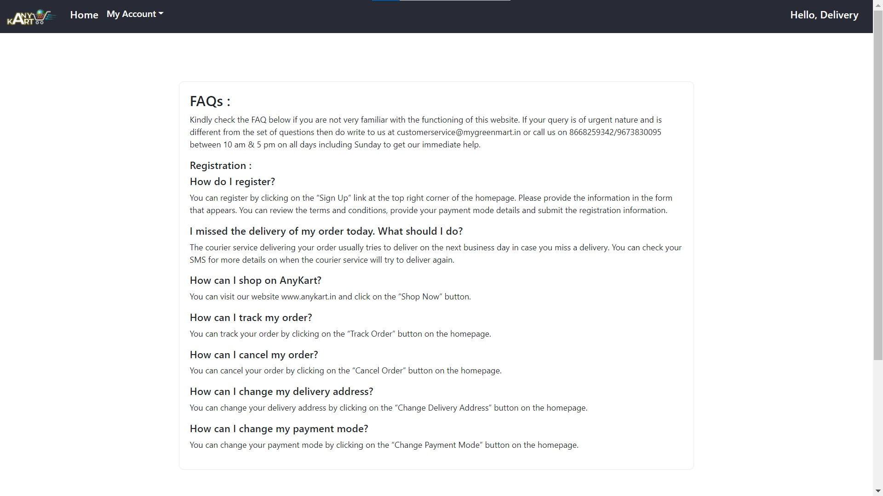

# CONCLUSION

The project entitled **AnyKart** was completed successfully.

The system has been developed with much care and free of errors and at the same time it is efficient and less time consuming. The purpose of this project was to develop a web application and an android application for purchasing items from a shop.

This project helped us in gaining valuable information and practical knowledge on several topics like designing web pages using React.js, usage of responsive templates, designing of android applications, and management of database using MySQL. The entire system is secured. Also, the project helped us understanding about the development phases of a project and software development life cycle. We learned how to test different features of a project.

This project has given us great satisfaction in having designed an application which can be implemented to any nearby shops or branded shops selling various kinds of products by simple modifications.

There is a scope for further development in our project to a great extent. A number of features can be added to this system in future like providing moderator more control over products so that each moderator can maintain their own products. Another feature we wished to implement was providing classes for customers so that different offers can be given to each class. System may keep track of history of purchases of each customer and provide suggestions based on their history. These features could have implemented unless the time did not limit us.

# REFERENCES

1. JavaScript Enlightenment, Cody Lindley-First Edition, based on JavaScript 1.5, ECMA-262,

Edition

1. Mc Graw Hill’s, Java: The complete reference 7thEdition, Herbert Scheldt
2. Complete CSS Guide, Maxine Sherrin and John Allsopp-O'ReillyMedia; September 2012

## ONLINE REFERENCE

* 1. [www.Google.com](http://www.google.com/)
  2. [www.w3school.com](http://www.w3school.com/)
  3. [www.javatpoint.com](http://www.javatpoint.com/)